**INDEX**

|  |  |  |  |  |
| --- | --- | --- | --- | --- |
| **Sr.No** | **Topic** |  | **Date** | **Remark** |
| **1** | **Write the following programs for Blockchain in Python :**   1. A Simple client class that generates the private and public keys by using the built in Python RSA algorithm and test it. 2. A transaction class to send and receive money and   test it. |  |  |  |
| **2** | **Write the following programs for Blockchain in Python :**   1. Create multiple transactions and display them. 2. Create a blockchain, a genesis block and execute it. |  |  |  |
| **3** | **Write the following programs for Blockchain in Python :**   1. Create a mining function and test it. 2. Add blocks to the miner and dump the blockchain. |  |  |  |
| **4** | **Implement and demonstrate the user of the following in Solidity :**   1. Variable 2. Operations 3. Loops 4. Decision Making   v. Strings |  |  |  |
| **5** | **Implement and demonstrate the user of the following in Solidity :**   1. Arrays 2. Enums 3. Structs 4. Mappings 5. Conversations 6. Ether Units 7. Special Variables |  |  |  |
| **6** | **Implement and demonstrate the user of the following in Solidity:**   1. Functions 2. View Functions 3. Pure Functions 4. Fallback Functions 5. Function Overloading 6. Mathematical Functions 7. Cryptographic Functions |  |  |  |
| **7** | **Implement and demonstrate the user of the following in Solidity:**   1. Contracts 2. Inheritance 3. Constructors 4. Abstract Class 5. Interfaces |  |  |  |
| **8** | **Implement and demonstrate the user of the following in Solidity:**   1. Libraries 2. Assembly 3. Events 4. Error Handling |  |  |  |

**PRACTICAL 1**

1. **Create a simple client class that generates the private and public keys by using the built-in python RSA algorithm and test it**
2. **A transaction class to send and receive money and test it**
3. **Create a simple client class that generates the private and public keys by using the built-in python RSA algorithm and test it**

**Code:**

#import random

from Crypto.PublicKey import RSA

from Crypto import Random

import binascii

from Crypto.Cipher import PKCS1_v1_5

class Client:

def __init__(self):

random=Random.new().read

self._private_key=RSA.generate(1024,random) #1024->key size

self._public_key=self._private_key.publickey()

self._signer=PKCS1_v1_5.new(self._private_key)

@property

def identity(self):

return binascii.hexlify(self._public_key.exportKey(format='DER')).decode('ascii')

Tanya=Client()

print('Tanya,27--> \n',Tanya.identity)

**Output:**

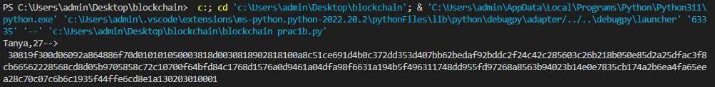

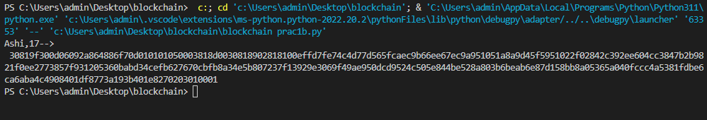

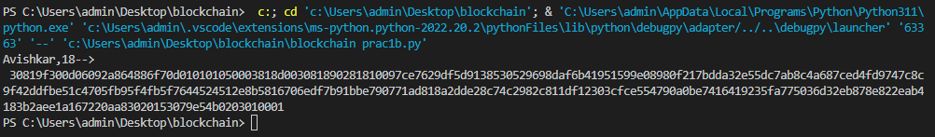

1. **A transaction class to send and receive money and test it**

*Genesis🡪1st block in blockchain*

**Code:**

#import random

from Crypto.PublicKey import RSA

from Crypto import Random

import binascii

from Crypto.Cipher import PKCS1_v1_5

from Crypto.Hash import SHA

import datetime

import collections

from Crypto.Signature import PKCS1_v1_5

from collections import OrderedDict

class Client:

def __init__(self):

random=Random.new().read

self._private_key=RSA.generate(1024,random) #1024->key size

self._public_key=self._private_key.publickey()

self._signer=PKCS1_v1_5.new(self._private_key)

@property

def identity(self):

return binascii.hexlify(self._public_key.exportKey(format='DER')).decode('ascii')

class Transaction:

def __init__(self,sender,receiver,value):

self.sender=sender

self.receiver=receiver

self.value=value

self.time=datetime.datetime.now()

def to_dict(self):

if self.sender=="Genesis":

identity="Genesis"

else:

identity=self.sender.identity

return collections.OrderedDict({

"sender":identity,

"receiver":self.receiver,

"value":self.value,

"time":self.time

})

def sign_tran(self):

private_key=self.sender._private_key

signer=PKCS1_v1_5.new(private_key)

h=SHA.new(str(self.to_dict).encode('utf-8'))

return binascii.hexlify(signer.sign(h)).decode('ascii')

def display_tran(transaction):

dict=transaction.to_dict()

print('\nsender,Tanya--> \n'+dict['sender'])

print('\nreceiver,Ashi--> \n'+dict['receiver'])

print('\nvalue--> \n'+str(dict['value']))

print('\ntime--> \n'+str(dict['time']))

transactions=[]

Tanya=Client()

Ashi= Client()

t1=Transaction(

Tanya,

Ashi.identity,

15)

t1.sign_tran()

display_tran(t1)

**Output:**

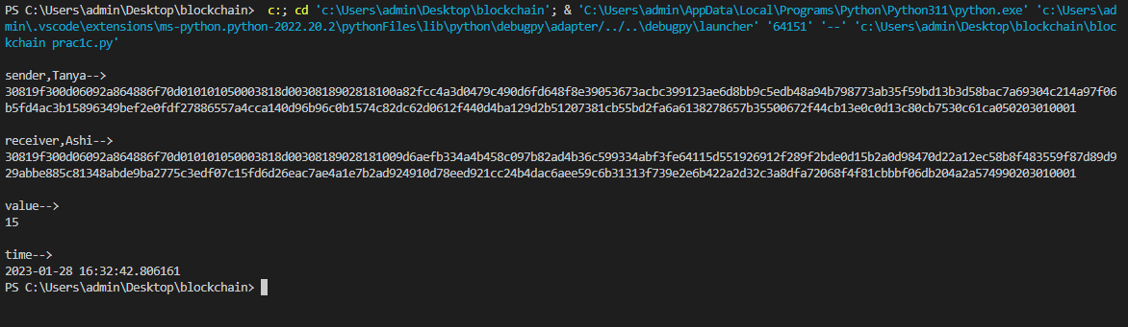

**PRACTICAL 2**

1. **Create multiple transactions and display them**
2. **Create a block chain a Genesis block and execute it**.
3. **Create multiple transactions and display them**

**Code:**

from Crypto.PublicKey import RSA

from Crypto import Random

from Crypto.Cipher import PKCS1_v1_5

import datetime

import binascii

from collections import OrderedDict

import collections

from Crypto.Hash import SHA

from Crypto.Signature import PKCS1_v1_5

class Client:

def __init__(self):

random = Random.new().read

self._private_key = RSA.generate(1024, random)

self._public_key = self._private_key.publickey()

self._signer = PKCS1_v1_5.new(self._private_key)

@property

def identity(self):

return binascii.hexlify(self._public_key.exportKey(format='DER')).decode('ascii')

class Transaction:

def __init__(self, sender, recipent, value):

self.sender = sender

self.recipent = recipent

self.value = value

self.time = datetime.datetime.now()

def to_dict(self):

if self.sender == "Genesis":

identity = "Genesis"

else:

identity = self.sender.identity

return collections.OrderedDict({

'sender': identity,

'recipent': self.recipent,

'value': self.value,

'time': self.time

})

def sign_tran(self):

private_key = self.sender._private_key

signer = PKCS1_v1_5.new(private_key)

h = SHA.new(str(self.to_dict()).encode('utf8'))

return binascii.hexlify(signer.sign(h)).decode('ascii')

def display_transaction(transaction):

# for transaction in transactions:

dict = transaction.to_dict()

print("sender:" + dict['sender'])

print('-----')

print("recipent:" + dict['recipent'])

print('-----')

print("value:" + str(dict['value']))

print('-----')

print("time:" + str(dict['time']))

print('-----')

transactions = []

Tanya = Client()

Avishkar = Client()

Nishi = Client()

t1 = Transaction(

Tanya,

Avishkar.identity,

15.0

)

t1.sign_tran()

transactions.append(t1)

t2 = Transaction(

Avishkar,

Nishi.identity,

17.0

)

t2.sign_tran()

transactions.append(t2)

t3 = Transaction(

Nishi,

Avishkar.identity,

10.0

)

t3.sign_tran()

transactions.append(t3)

tn = 1

for t in transactions:

print("Transaction: ", tn)

display_transaction(t)

tn = tn + 1

print('-------------------')

**Output:**

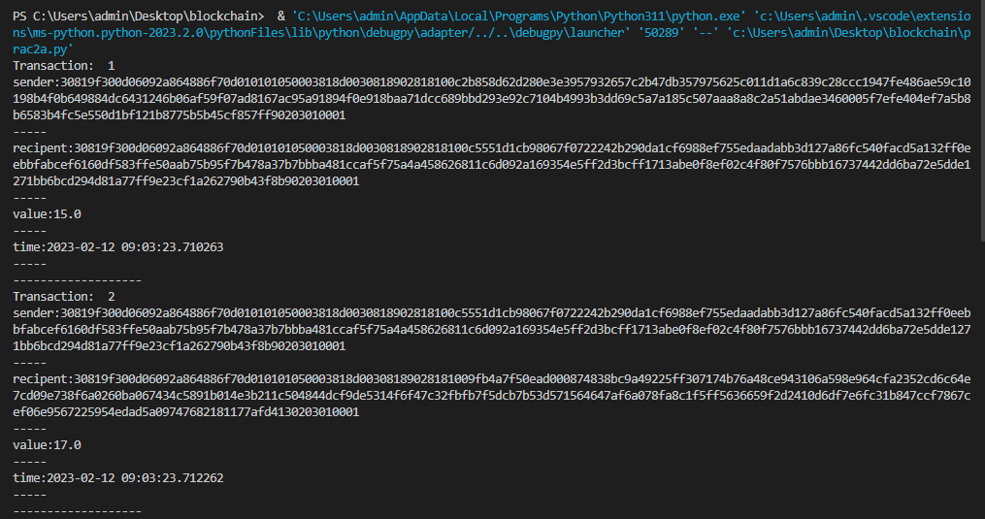

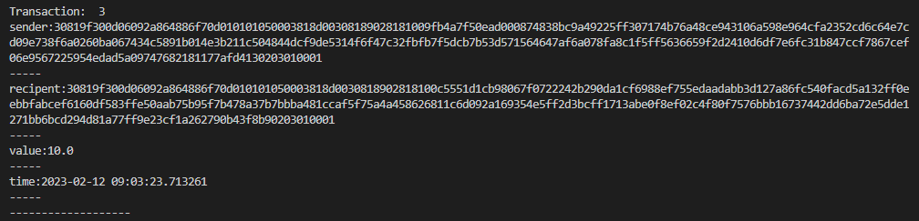

1. **Create a block chain a Genesis block and execute it**.

*Noance: a randomly generated number (unique) used once in cryptography transaction*

**Code:**

from Crypto.PublicKey import RSA

from Crypto import Random

from Crypto.Cipher import PKCS1_v1_5

import datetime

import binascii

from collections import OrderedDict

import collections

from Crypto.Hash import SHA

from Crypto.Signature import PKCS1_v1_5

class Client:

def __init__(self):

random = Random.new().read

self._private_key = RSA.generate(1024, random)

self._public_key = self._private_key.publickey()

self._signer = PKCS1_v1_5.new(self._private_key)

@property

def identity(self):

return binascii.hexlify(self._public_key.exportKey(format='DER')).decode('ascii')

class Transaction:

def __init__(self, sender, recipent, value):

self.sender = sender

self.recipent = recipent

self.value = value

self.time = datetime.datetime.now()

def to_dict(self):

if self.sender == "Genesis":

identity = "Genesis"

else:

identity = self.sender.identity

return collections.OrderedDict({

'sender': identity,

'recipent': self.recipent,

'value': self.value,

'time': self.time

})

def sign_tran(self):

private_key = self.sender._private_key

signer = PKCS1_v1_5.new(private_key)

h = SHA.new(str(self.to_dict()).encode('utf8'))

return binascii.hexlify(signer.sign(h)).decode('ascii')

def display_transaction(transaction):

# for transaction in transactions:

dict = transaction.to_dict()

print("sender:" + dict['sender'])

print('-----')

print("recipent:" + dict['recipent'])

print('-----')

print("value:" + str(dict['value']))

print('-----')

print("time:" + str(dict['time']))

print('-----')

def dump_blockchain(self):

print("Number of blocks in the chain:" + str(len(self)))

for x in range (len(TPCoins)):

block_temp=TPCoins[x]

print("block#" + str(x))

for transaction in block_temp.verified_transaction:

display_transaction(transaction)

print("...............")

print("====================")

class Block:

def __init__(self):

self.verified_transaction=[]

self.previous_block_hash=""

self.Nonce=""

Tanya = Client()

t0=Transaction(

"Genesis",

Tanya.identity,

500.0

)

block0=Block()

block0.previous_block_hash=None

Nonce=None

block0.verified_transaction.append(t0)

digest=hash(block0)

last_block_hash = digest

TPCoins=[]

TPCoins.append(block0)

dump_blockchain(TPCoins)

**Output:**

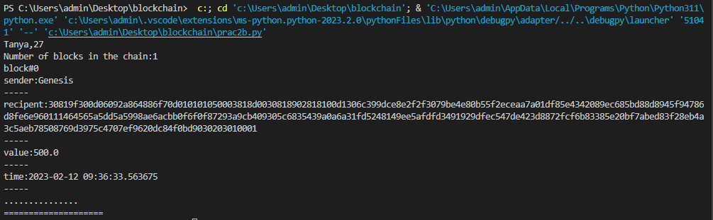

**PRACTICAL 3**

1. **Create a mining function and test it.**
2. **Add block to miner and dump the block chain.**
3. **Create a mining function and test it.**

*Miners: verifies the transactions in block chain*

**Code:**

print("Tanya,27")

import hashlib

def sha256(message):

return hashlib.sha256(message.encode('ascii')).hexdigest()

def mine(message,difficulty=1):

assert difficulty>=1 #debugging

prefix= '1'* difficulty #verify diffficulty

print ("prefix",prefix)

for i in range(1000):

digest = sha256(str(hash(message)) + str(i))

print("Testing --> " + digest)

if digest.startswith(prefix):

print("After" + str(i) + "iterations found nounce" + digest)

return i

mine("Tanya", 3)

**Output:**

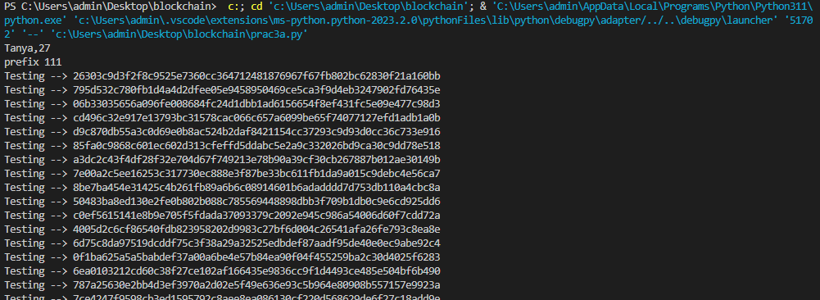



1. **Add block to miner and dump the block chain.**

*Miners: verifies the transactions in block chain*

**Code:**

from Crypto.PublicKey import RSA

from Crypto import Random

from Crypto.Cipher import PKCS1_v1_5

import datetime

import binascii

from collections import OrderedDict

import collections

from Crypto.Hash import SHA

from Crypto.Signature import PKCS1_v1_5

import hashlib

print("Tanya,27")

class Client:

def __init__(self):

random = Random.new().read

self._private_key = RSA.generate(1024, random)

self._public_key = self._private_key.publickey()

self._signer = PKCS1_v1_5.new(self._private_key)

@property

def identity(self):

return binascii.hexlify(self._public_key.exportKey(format='DER')).decode('ascii')

class Transaction:

def __init__(self, sender, recipent, value):

self.sender = sender

self.recipent = recipent

self.value = value

self.time = datetime.datetime.now()

def to_dict(self):

if self.sender == "Genesis":

identity = "Genesis"

else:

identity = self.sender.identity

return collections.OrderedDict({

'sender': identity,

'recipent': self.recipent,

'value': self.value,

'time': self.time

})

def sign_tran(self):

private_key = self.sender._private_key

signer = PKCS1_v1_5.new(private_key)

h = SHA.new(str(self.to_dict()).encode('utf8'))

return binascii.hexlify(signer.sign(h)).decode('ascii')

def display_transaction(transaction):

# for transaction in transactions:

dict = transaction.to_dict()

print("sender:" + dict['sender'])

print('-----')

print("recipent:" + dict['recipent'])

print('-----')

print("value:" + str(dict['value']))

print('-----')

print("time:" + str(dict['time']))

print('-----')

def dump_blockchain(self):

print("Number of blocks in the chain:" + str(len(self)))

for x in range (len(TPCoins)):

block_temp=TPCoins[x]

print("block#" + str(x))

for transaction in block_temp.verified_transaction:

display_transaction(transaction)

print("...............")

print("====================")

class Block:

def __init__(self):

self.verified_transaction=[]

self.previous_block_hash=""

self.Nonce=""

def sha256(message):

return hashlib.sha256(message.encode('ascii')).hexdigest()

def mine(message,difficulty=1):

assert difficulty>=1 #debugging

prefix= '1'* difficulty #verify diffficulty

print ("prefix",prefix)

for i in range(1000):

digest = sha256(str(hash(message)) + str(i))

print("Testing --> " + digest)

if digest.startswith(prefix):

print("After " + str(i) + "iterations found nounce " + digest)

return i

mine("Tanya", 3)

transactions = []

Tanya = Client()

Avishkar = Client()

Nishi = Client()

t0=Transaction(

"Genesis",

Tanya.identity,

500.0

)

t1 = Transaction(

Tanya,

Avishkar.identity,

15.0

)

t1.sign_tran()

transactions.append(t1)

t2 = Transaction(

Avishkar,

Nishi.identity,

17.0

)

t2.sign_tran()

transactions.append(t2)

t3 = Transaction(

Nishi,

Avishkar.identity,

10.0

)

#blockchain

TPCoins=[]

block0=Block()

block0.previous_block_hash=None

Nonce=None

block0.verified_transaction.append(t0)

digest=hash(block0)

last_block_hash = digest

last_block_hash=digest

TPCoins.append(block0)

block1=Block()

block1.previous_block_hash=last_block_hash

block1.verified_transaction.append(t1)

block1.verified_transaction.append(t2)

block1.Nonce=mine(block1,2)

digest=hash(block1)

last_block_hash=digest

TPCoins.append(block1)

block2=Block()

block2.previous_block_hash=last_block_hash

block2.verified_transaction.append(t3)

Nonce=mine(block2,2)

block2.Nonce=mine(block2,2)

digest=hash(block2)

last_block_hash=digest

TPCoins.append(block2)

dump_blockchain(TPCoins)

**Output:**

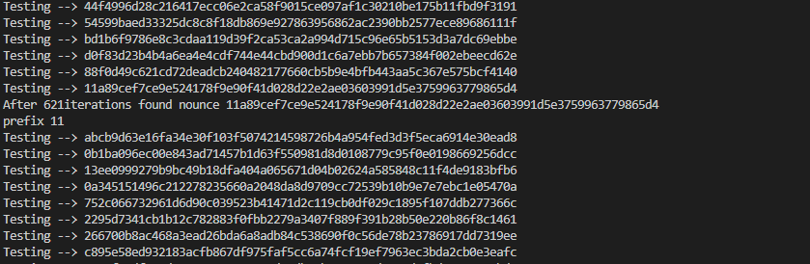

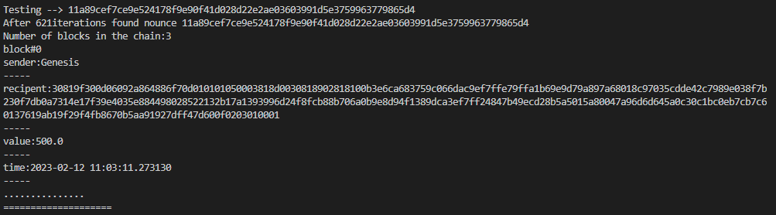

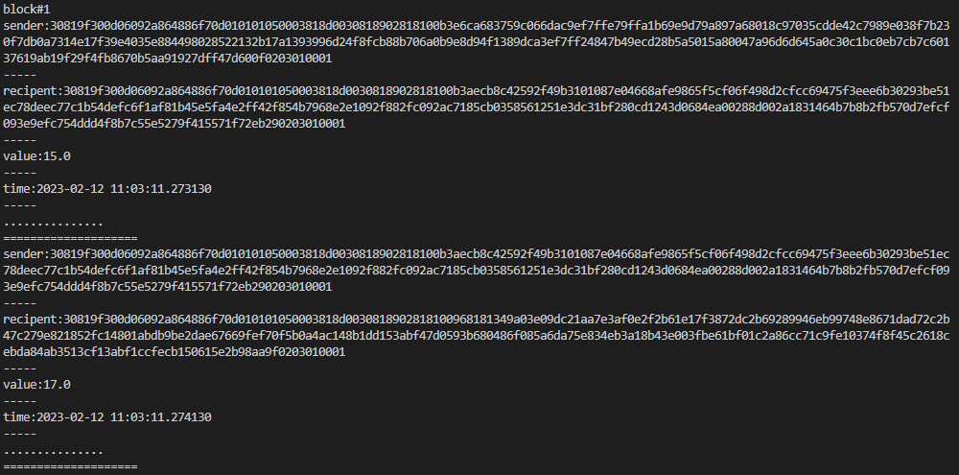

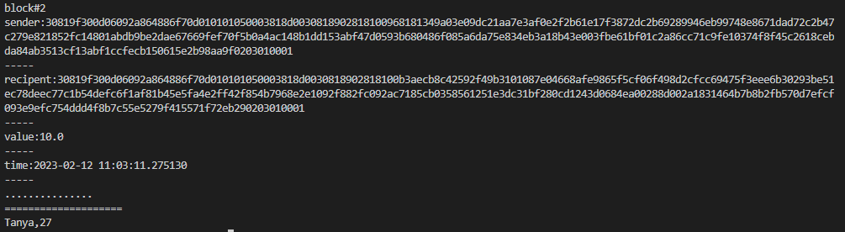

**PRACTICAL 4**

1. **Variable**
2. **Operations**
3. **Loops**
4. **Decision Making**
5. **Strings**
6. **Variable**

**Code:**

pragma solidity ^0.8.0;

contract SolidityTest {

uint storedData; // State variable

constructor() public{

storedData=10;

}

function getDiv() public view returns(uint){

uint a=10; // local variable

uint b=2;

uint result = a / b;

return result; // accesss the state variable

}}

**Output:**

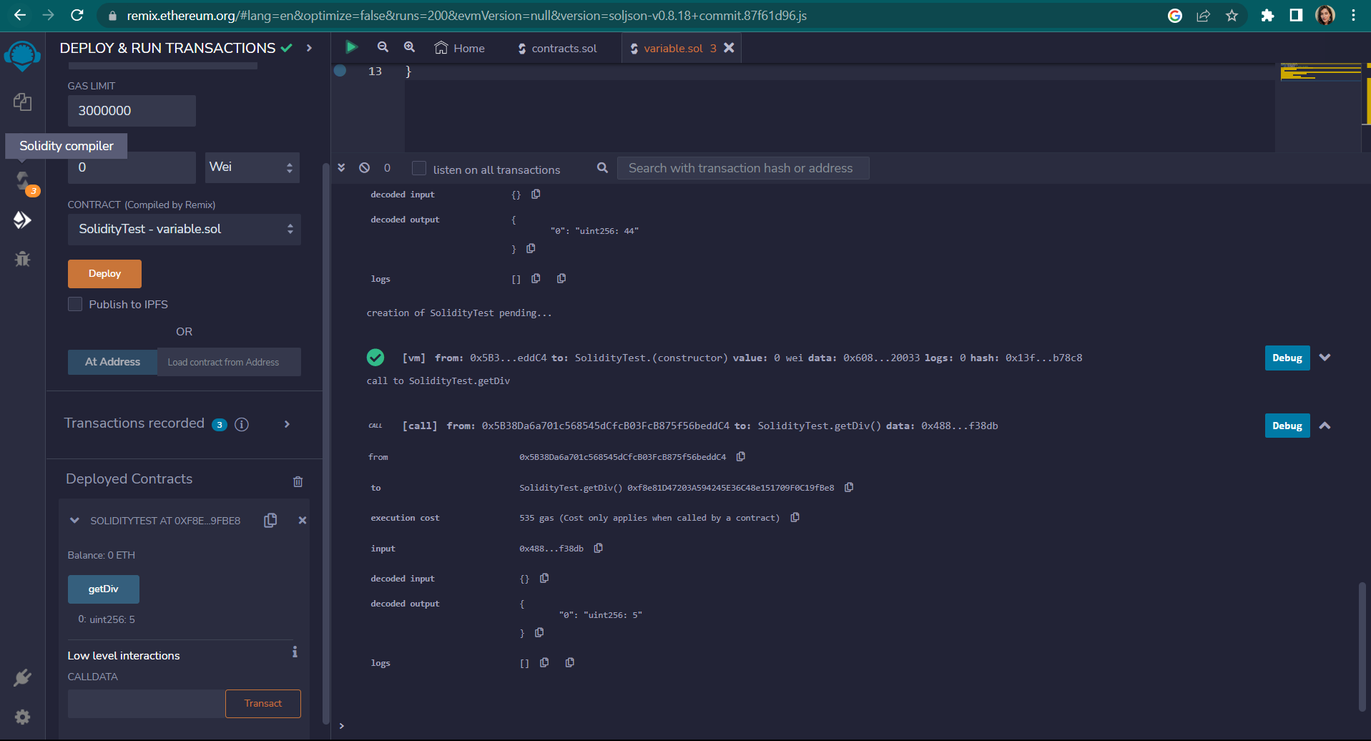

1. **Operations**

**Code:**

pragma solidity ^0.8.0;

contract SolidityTest {

uint storedData; // State variable

constructor() public{

storedData=10;

}

function getDiv() public view returns(uint){

uint a=50; // local variable

uint b=5;

uint result = a / b;

return result; // accesss the state variable

}

function getMul() public view returns(uint){

uint a=50; // local variable

uint b=5;

uint result = a * b;

return result; // accesss the state variable

}

function getSum() public view returns(uint){

uint a=50; // local variable

uint b=5;

uint result = a + b;

return result; // accesss the state variable

}

function getSub() public view returns(uint){

uint a=50; // local variable

uint b=5;

uint result = a - b;

return result; // accesss the state variable

}}

**Output:**

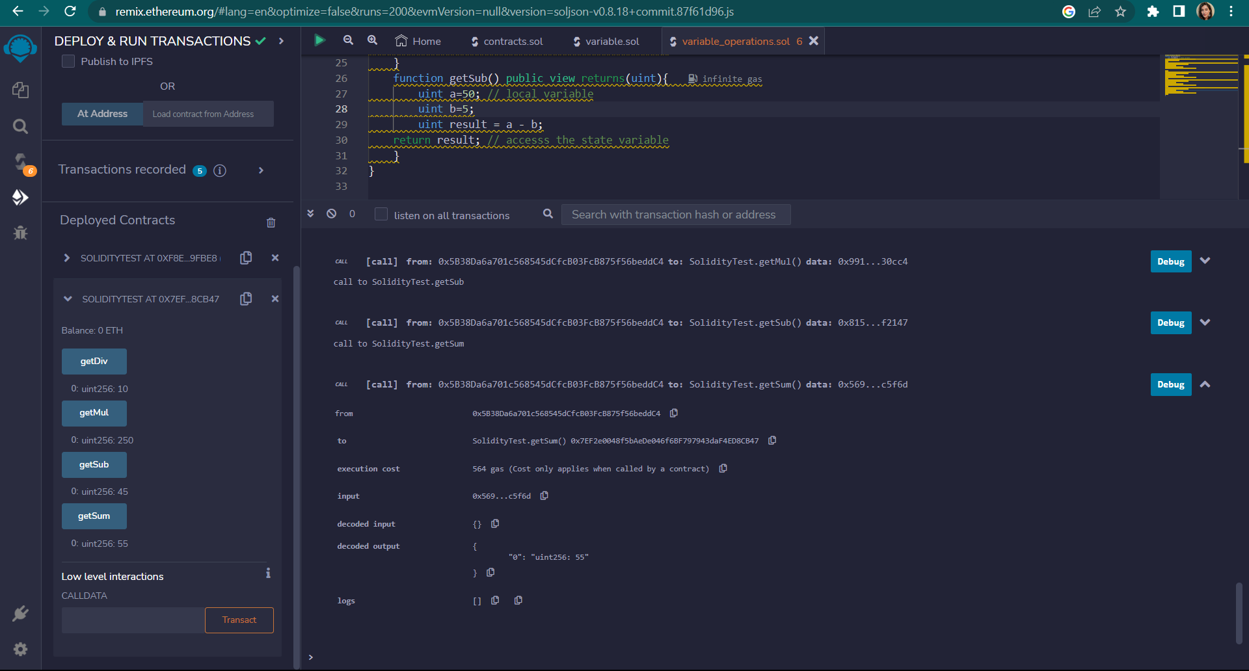

1. **Loops**
   1. **While**

**Code:**

pragma solidity ^0.8.0;

contract while1{

uint[] data;

uint8 j=0;

function loop() public returns(uint[] memory)

{

while (j<10)

{

j++;

data.push(j);

}

return data;

}

}

**Output:**

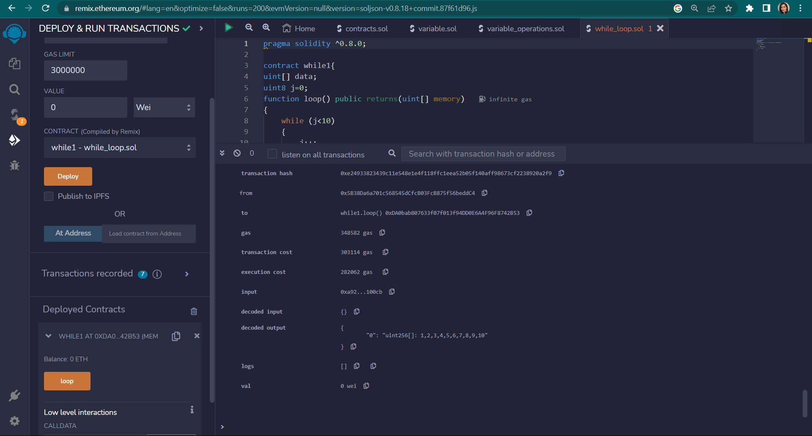

* 1. **Do While**

**Code:**

pragma solidity ^0.8.0;

contract doWhile1{

uint[] data;

uint8 j=0;

function loop() public returns(uint[] memory)

{

do

{

j++;

data.push(j);

}

while (j<10);

return data;

}

}

**Output:**

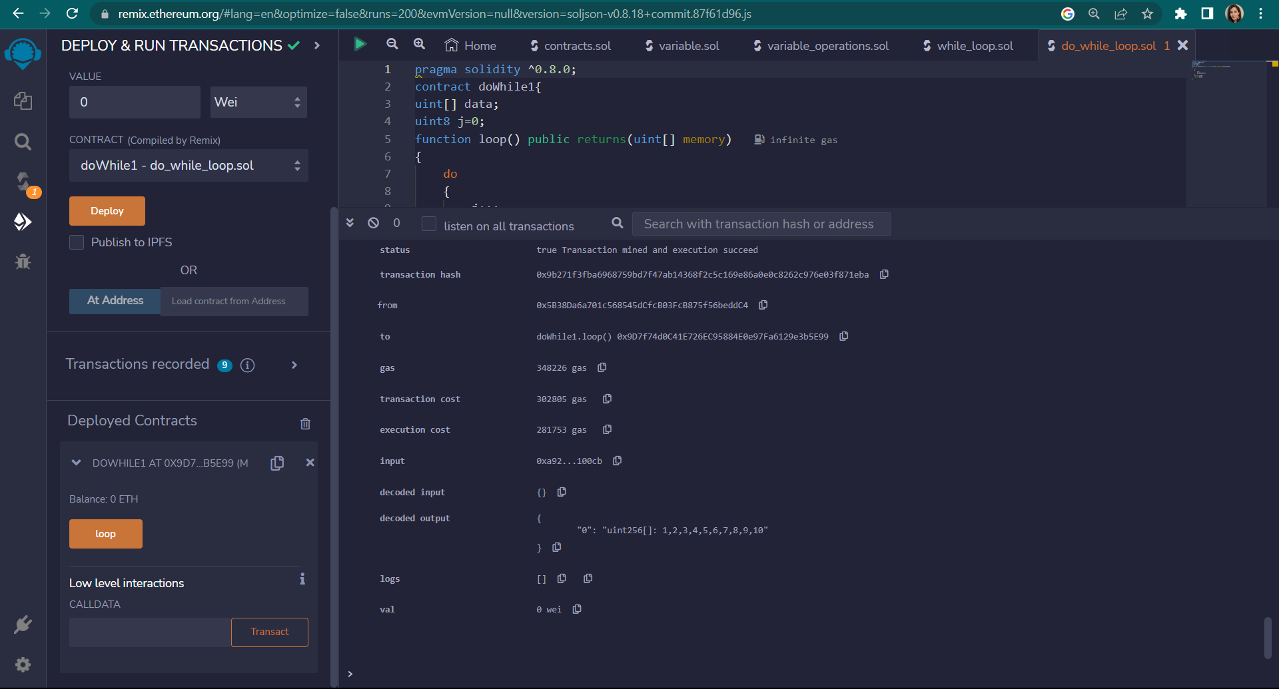

* 1. **For**

**Code:**

pragma solidity ^0.8.0;

contract ForLoop{

function count() public pure returns(uint256){

uint256 sum=0;

for(uint256 i=0;i<=25;i++){

sum+=i;

}

return sum;

}}

**Output:**

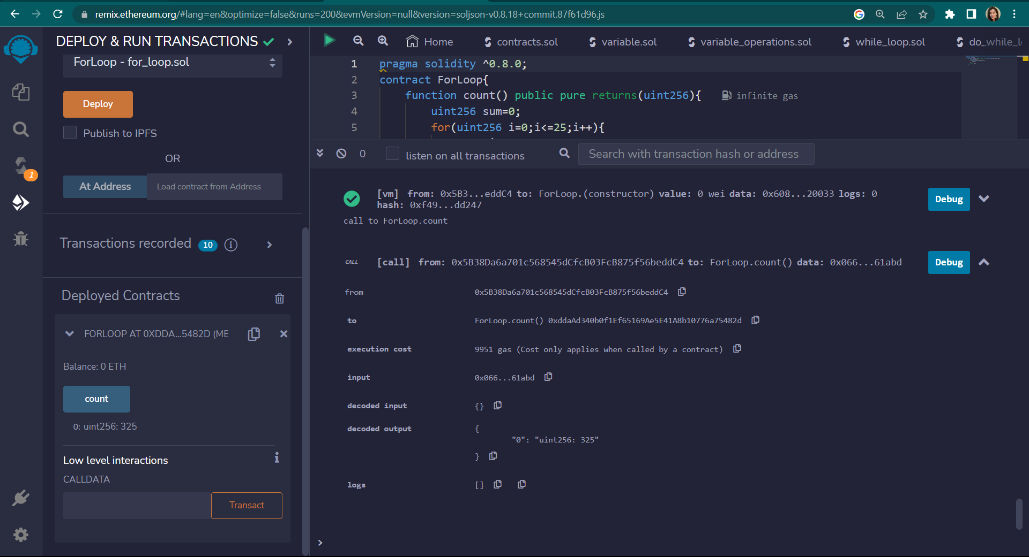

1. **Decision Making**
   1. **If else**

**Code:**

pragma solidity ^0.8.0;

contract Check{

uint i=100;

uint j=80;

function ifElse() public returns(string memory)

{

if(i<j)

{

return "i is smaller than j";

}

else

{

return " i is greater than j";

} }}

**Output:**

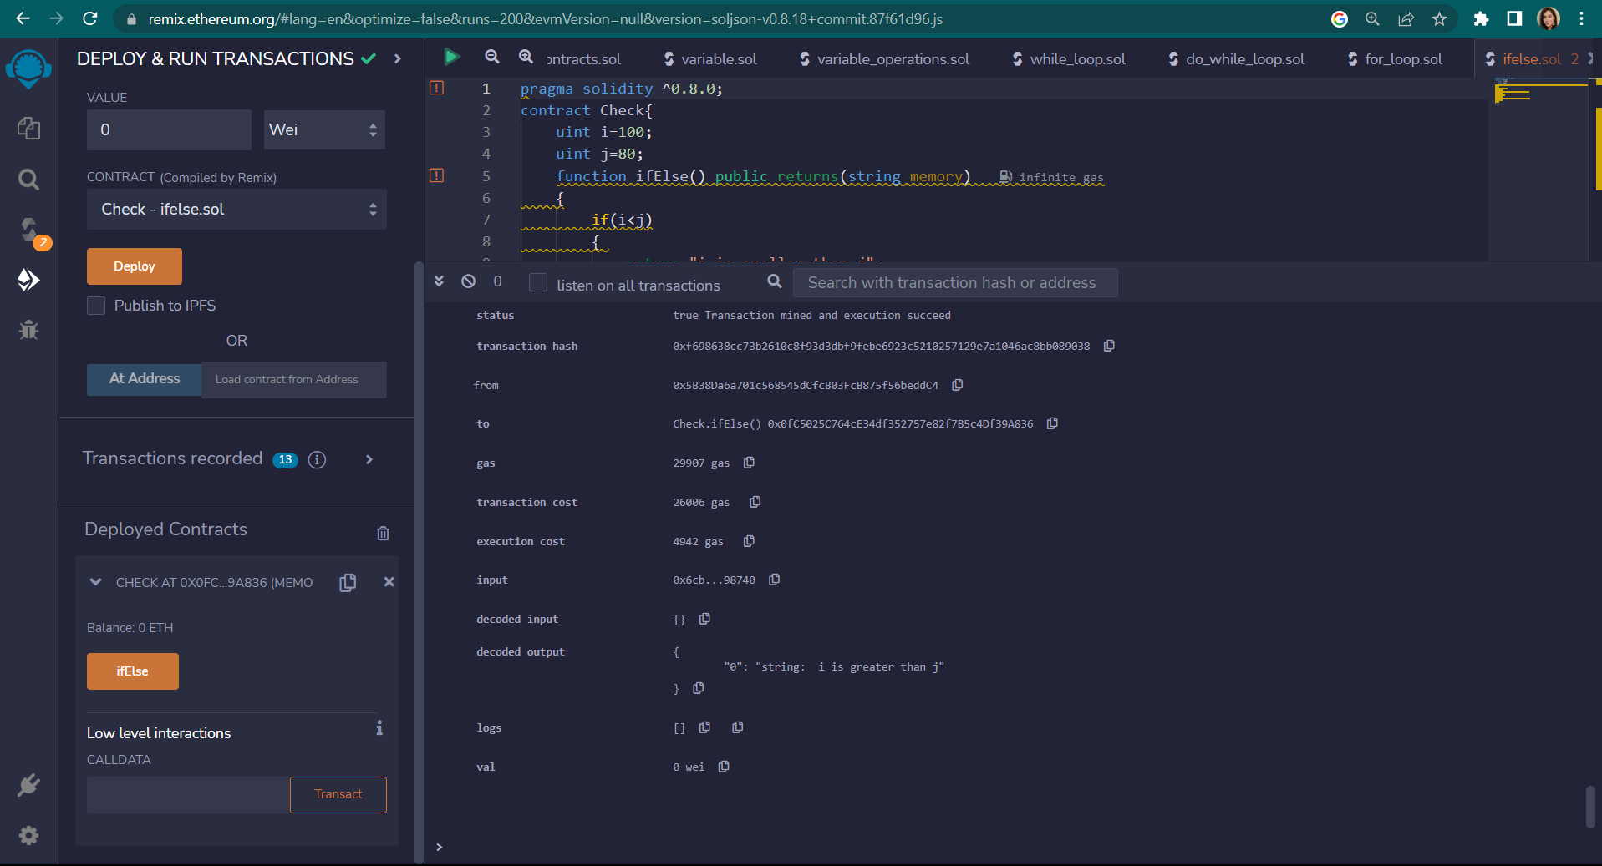

* 1. **If else-if**

**Code:**

pragma solidity ^0.8.0;

contract Check{

uint i=100;

uint j=100;

function ifElseIf() public returns(string memory)

{

if(i<j)

{

return "i is smaller than j";}

else if(i>j)

{

return " i is greater than j"; }

else

{

return " i is equal to j";

}}}

**Output:**

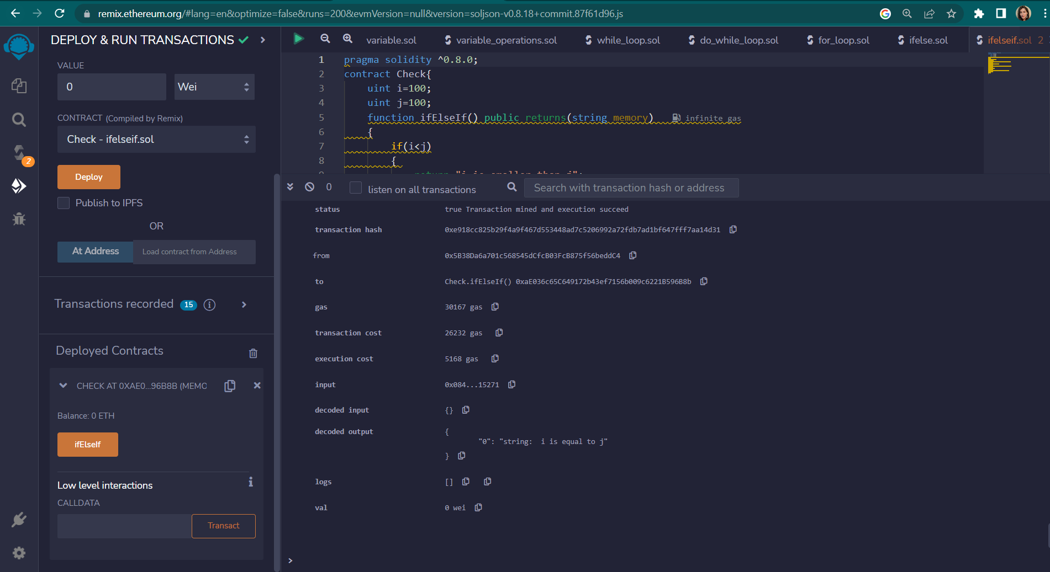

1. **Strings**
   1. **Regular string**

**Code:**

pragma solidity ^0.8.0;

contract SS{

string str1="M.SC I.T PART 2";

string str2='K.C COLLEGE, COLABA';

string str3=new string(20);

function getstr1() public returns(string memory)

{

return str1; }

function getstr2() public returns(string memory)

{

return str2; }

function getstr3() public returns(string memory)

{

return str3;

}}

**Output:**

**String1:**

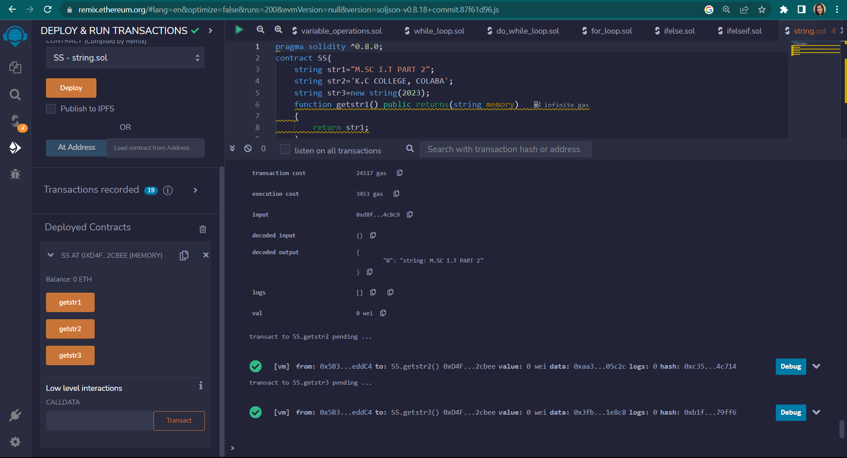

**String2:**

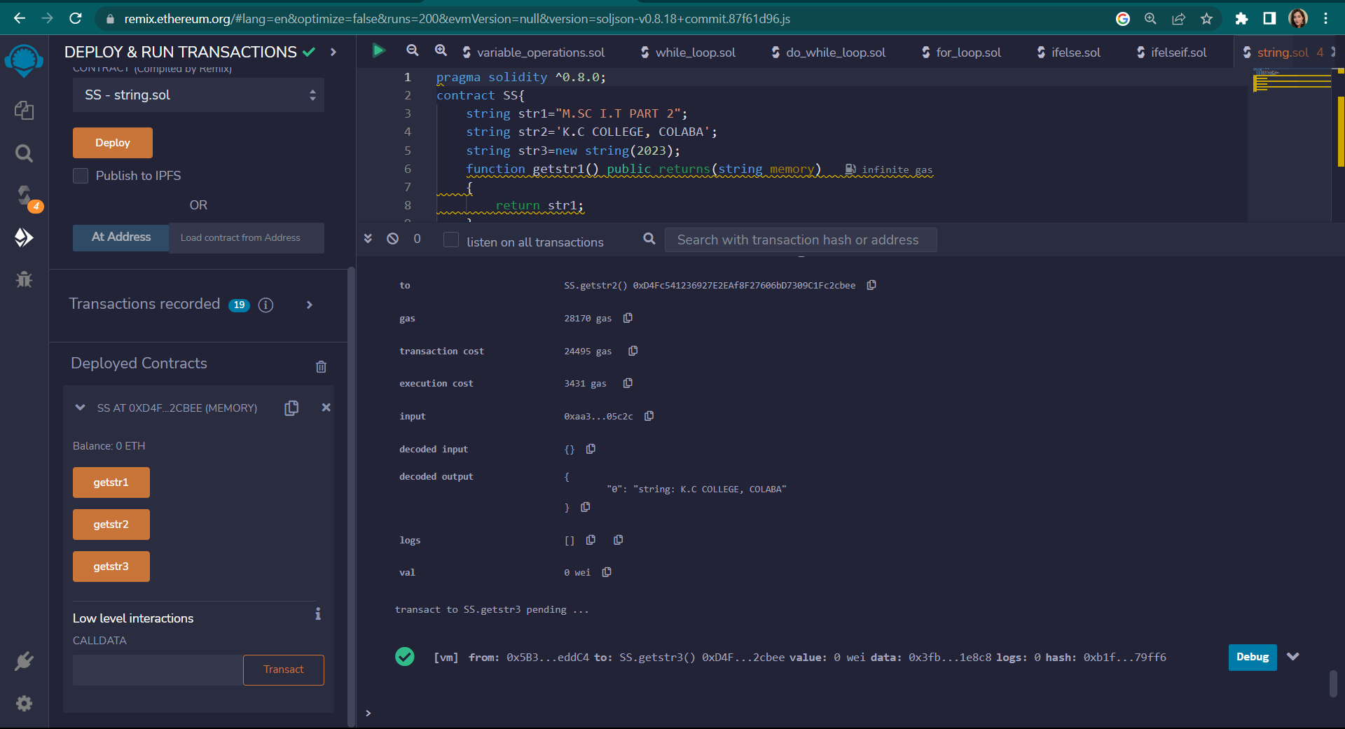

**String3:**

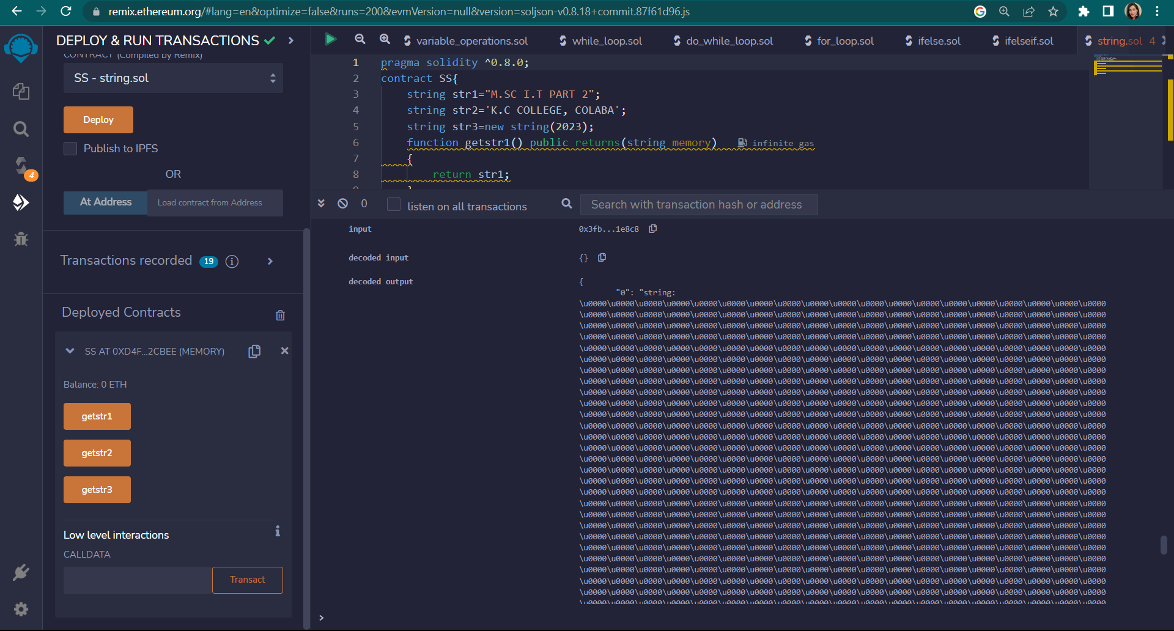

* 1. **Concatenate**

**Code:**

pragma solidity >=0.5.0 <0.9.0;

contract Demo{

string public s1 = "Tanya ";

string public s2 = "Panchal";

string public new_str;

function concatenate() public {

new_str = string(abi.encodePacked(s1, s2));

}

}

**Output:**

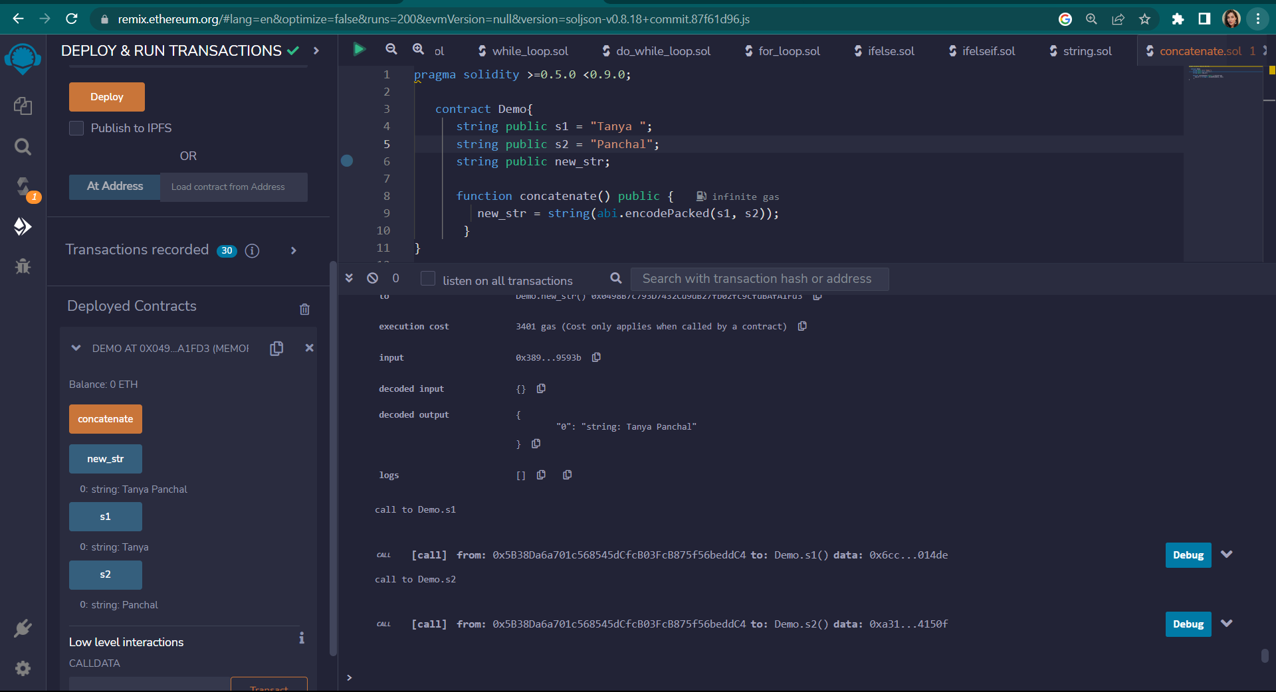

* 1. **Compare**

**Code:**

pragma solidity ^0.8.0;

contract Demo{

string str1="TANYA";

string str2='TANYA';

bool public isEqual;

function cmp() public

{

isEqual=keccak256(abi.encodePacked(str1))==keccak256(abi.encodePacked(str2));

}

}

**Output:**

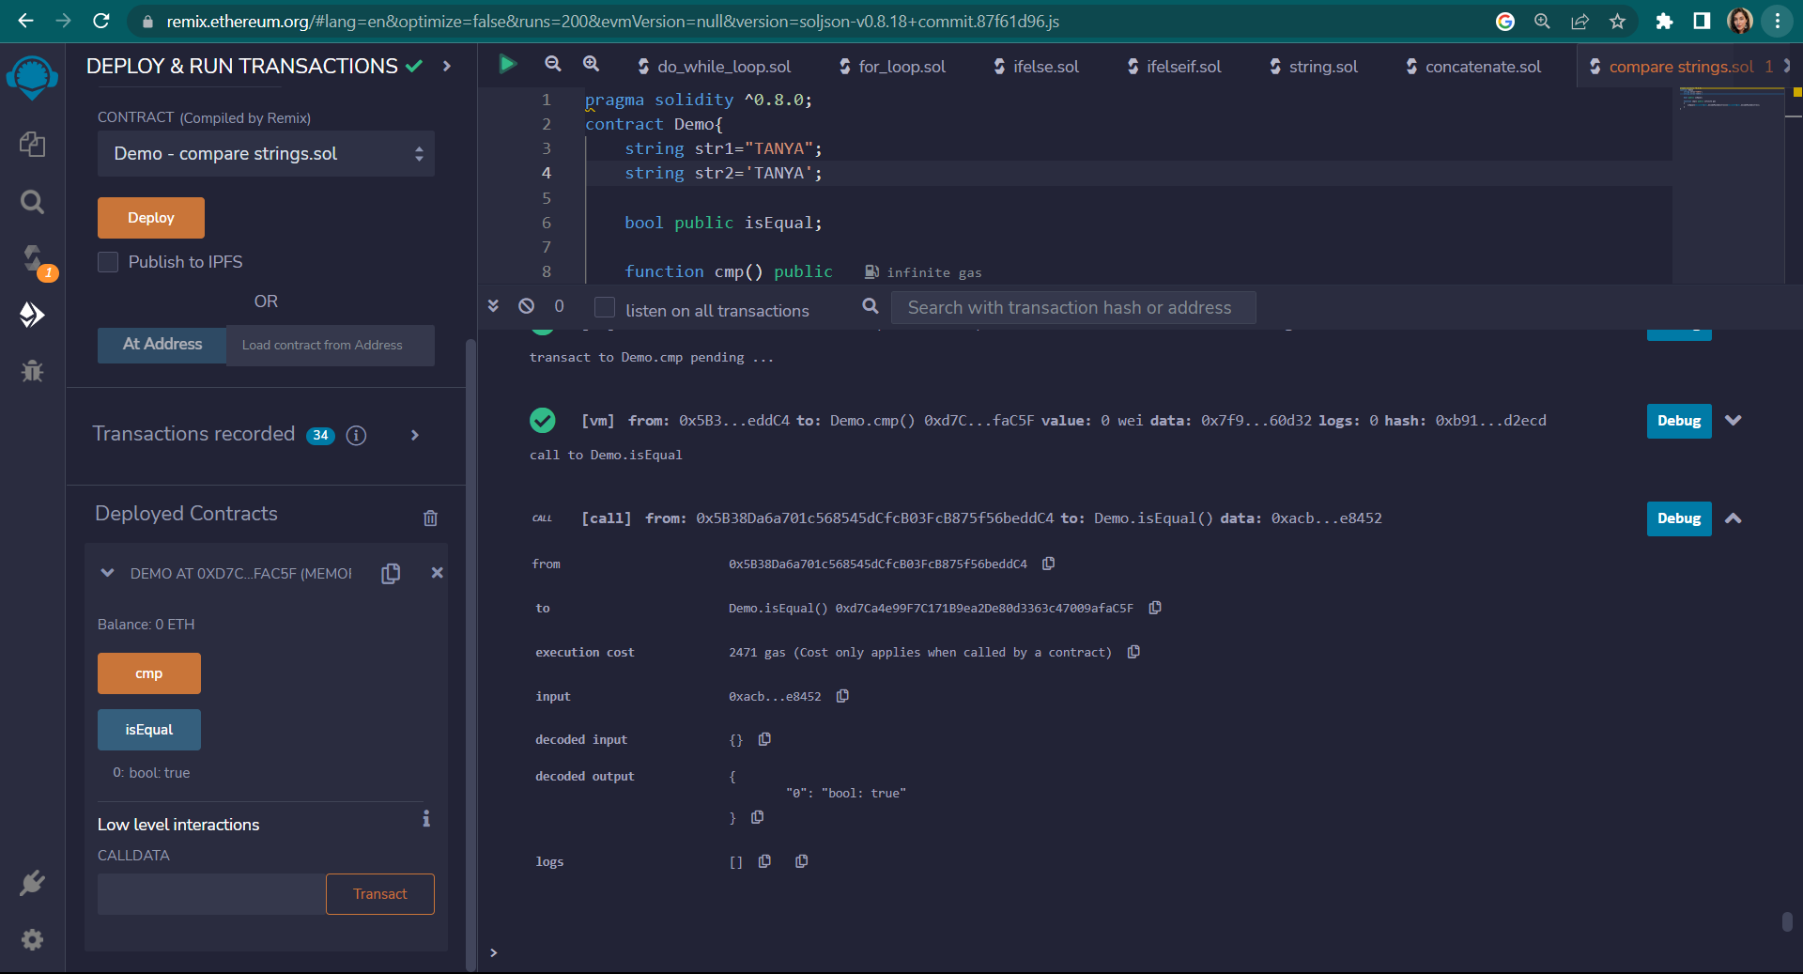

**PRACTICAL 5**

1. **Arrays**
2. **Enums**
3. **Structs**
4. **Mappings**
5. **Conversations**
6. **Ether Units**
7. **Special Variables**
8. **Arrays**

**Code:**

pragma solidity ^0.5.0;

contract Arrray{

uint[] nums=[1,2,33,21];

function getlength() public returns(uint){

return nums.length;

}

function pop() public{

delete nums[1];

}

function push() public returns (uint[] memory){

nums.push(7);

return nums;

}

function push1(uint i) public{

nums.push(i);

}

}

**Output:**

**Push:**

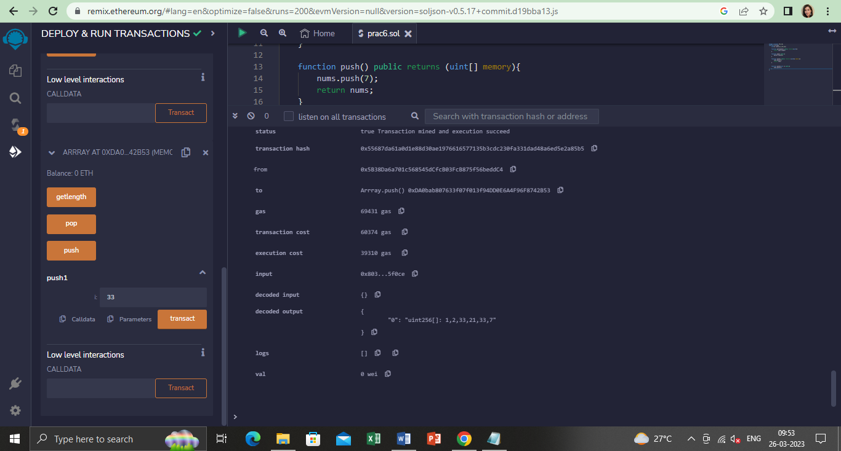

**Pop:**

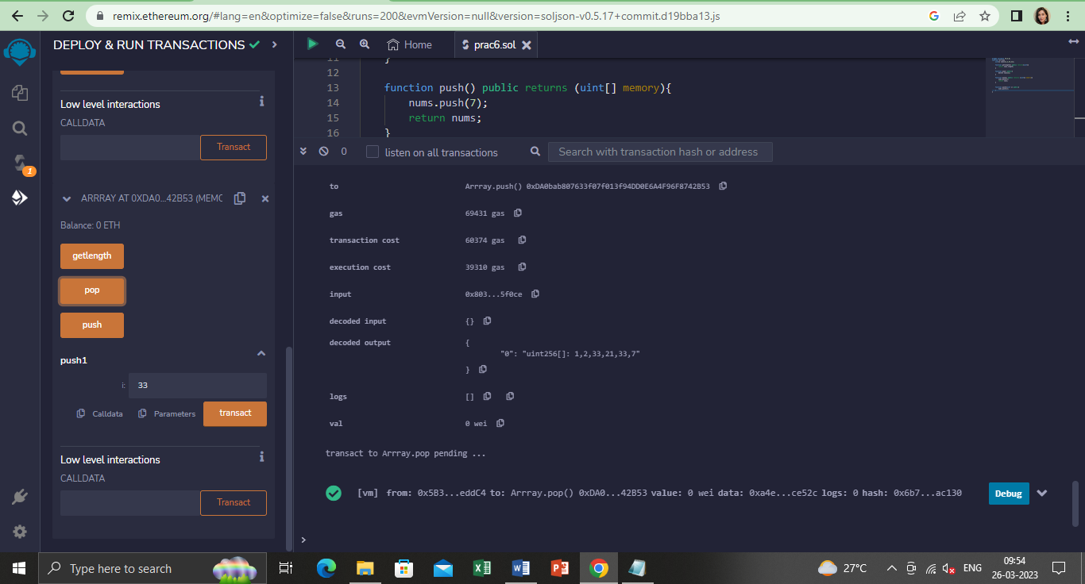

**Dynamic:**

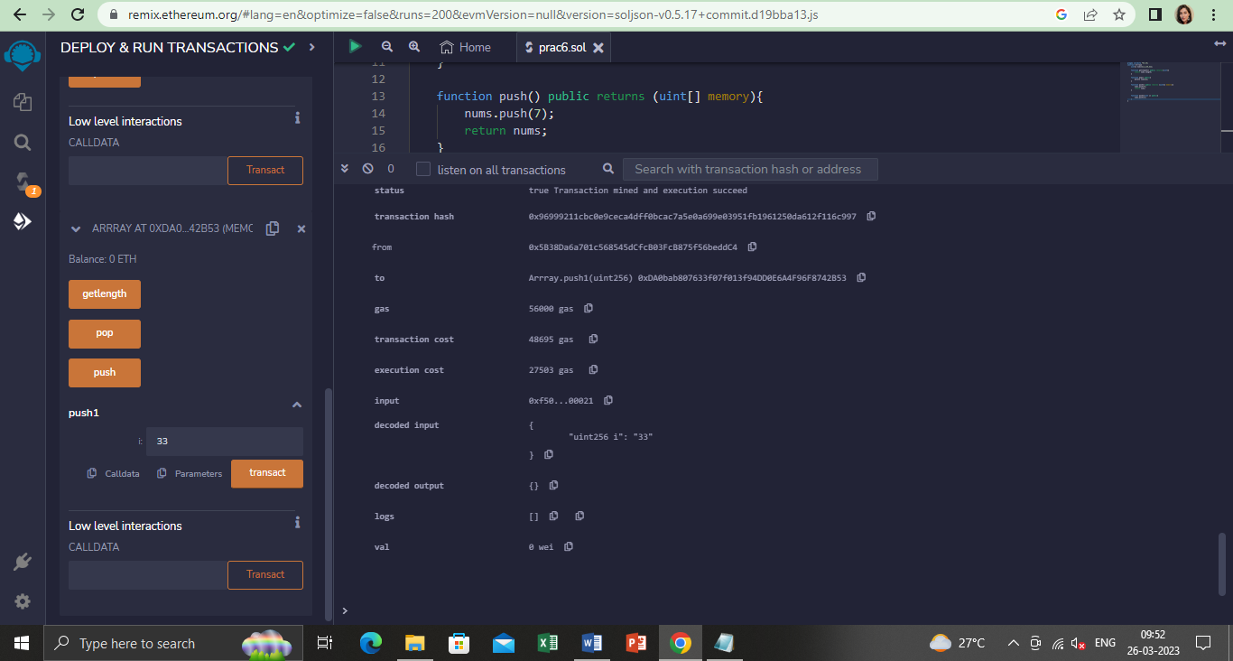

1. **Struct**

**Code:**

pragma solidity ^0.5.0;

contract test{

struct Book{

string title;

string author;

string name;

uint book_id;

}

Book book;

function setBook() public{

book = Book('SOLIDITY','JOHN','fantasy world',101);

}

function getBookId() public view returns(uint){

return book.book_id;

}

function getName() public view returns(string memory){

return book.name;

}

function getBookDeets() public view returns(string memory,string memory,string memory){

return(book.title,book.name,book.author);

}

}

**Output:**

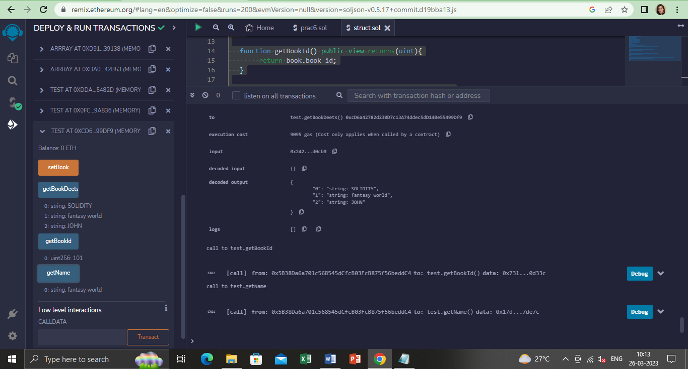

1. **Enum**

**Code:**

pragma solidity ^0.5.0;

contract Types{

enum week_days{

Monday,

Tuesday,

Wednesday,

Thursday,

Friday,

Saturday,

Sunday

}

week_days week;

week_days choice;

week_days constant default_value = week_days.Sunday;

function set_value() public{

choice = week_days.Wednesday;

}

function get_choice() public view returns(week_days){

return choice;

}

}

**Output:**

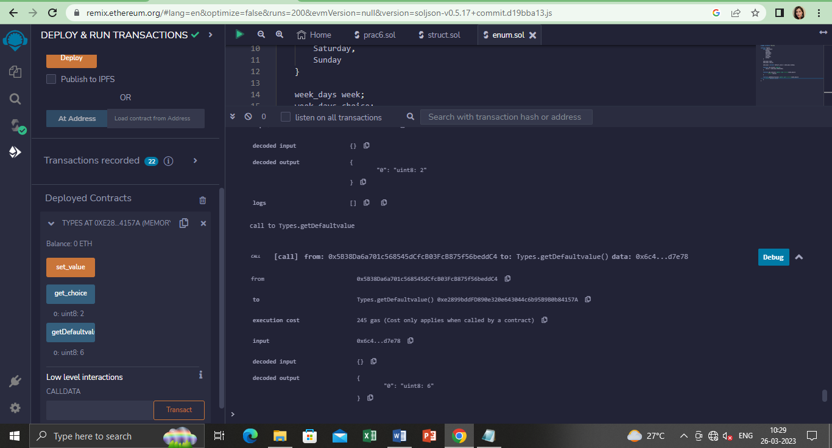

1. **Mapping**

**Code:**

pragma solidity ^0.5.0;

contract LedgerBalance{

mapping(address => uint) balance;

mapping(address => string) name;

function updateBalance() public returns(uint){

balance[msg.sender]=20;

return balance[msg.sender];

}

function senderInfo() public returns(string memory){

name[msg.sender] = "tanya";

return name[msg.sender];

}

function printSender() public view returns(address){

return msg.sender;

}

}

**Output:**

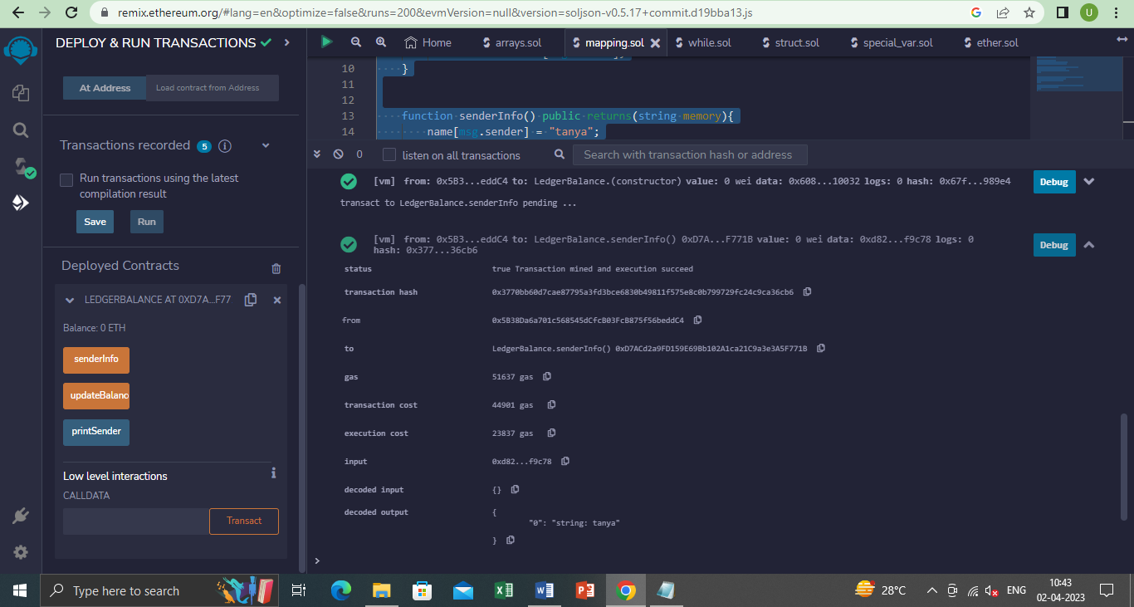

1. **6. Conversions and Ether units**

**keccak256**

**Code**:

pragma solidity >=0.4.0 <0.7.0;

contract EtherUnitsExample {

uint256 public valueInWei = 1 ether; // 1 ether in Wei

uint256 public valueInFinney = 1 finney; // 1 finney in Wei

uint256 public valueInSzabo = 1 szabo; // 1 szabo in Wei

uint256 public valueInEther = 1 ether; // 1 ether in Wei

function convert(uint256 _amount, string memory _unit) public pure returns (uint256) {

if (keccak256(abi.encodePacked(_unit)) == keccak256(abi.encodePacked("wei"))) {

return _amount;

} else if (keccak256(abi.encodePacked(_unit)) == keccak256(abi.encodePacked("finney"))) {

return _amount * 1 finney;

} else if (keccak256(abi.encodePacked(_unit)) == keccak256(abi.encodePacked("szabo"))) {

return _amount * 1 szabo;

} else if (keccak256(abi.encodePacked(_unit)) == keccak256(abi.encodePacked("ether")) || keccak256(abi.encodePacked(_unit)) == keccak256(abi.encodePacked("eth"))) {

return _amount * 1 ether;

} else {

revert("Invalid unit");

}

}}

**Output**:

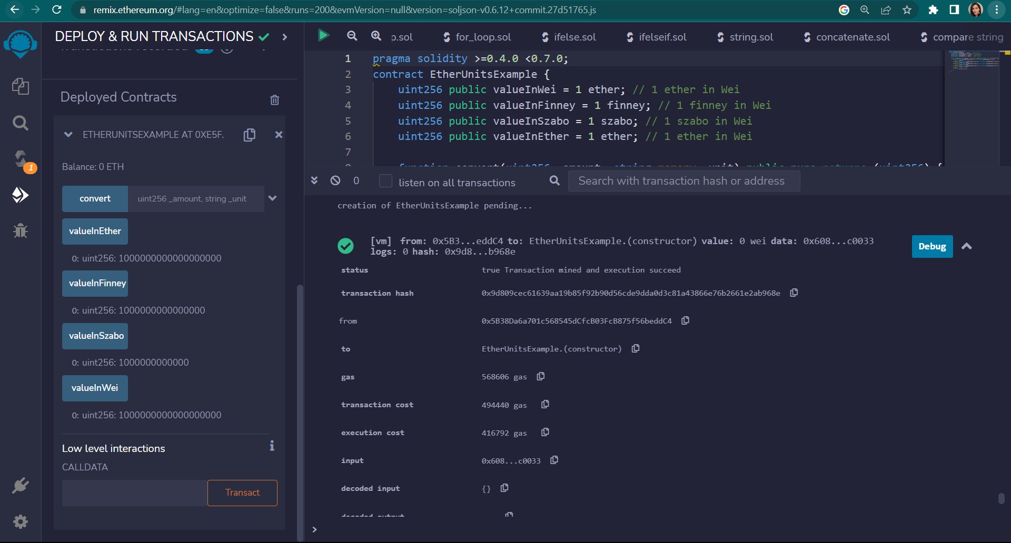

**7. Special variables:**

* 1. **Solidity contract to demonstrate the special variables block.number and blockhash.**

**Code**:

pragma solidity ^0.5.0;

contract prac

{

uint BNumber;

bytes32 BHashPresent;

bytes32 BHashPrevious;

function PresentHash()

public returns(bytes32)

{

BNumber = block.number;

BHashPresent =blockhash(BNumber);

return BHashPresent;

}

function PreviousHash()

public returns(bytes32)

{

BNumber = block.number;

BHashPrevious = blockhash(BNumber - 1);

return BHashPrevious;

}

}

**Output**:

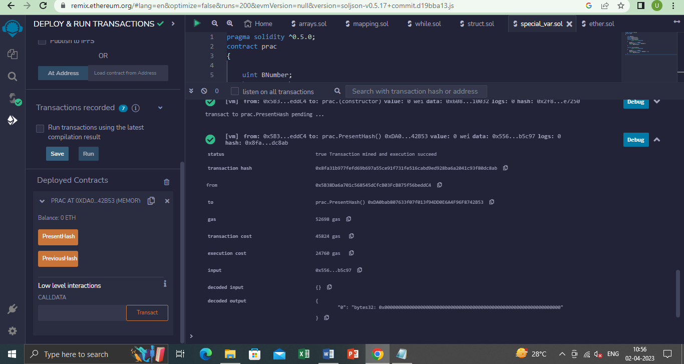

* 1. **Solidity contract to demonstrate msg.sender**

**Code**:

pragma solidity ^0.5.0;

contract LedgerBalance{

mapping(address => string) name;

function senderInfo() public returns(string memory){

name[msg.sender] = "tanya";

return name[msg.sender];

}

function printSender() public view returns(address){

return msg.sender;

}

}

**Output**:

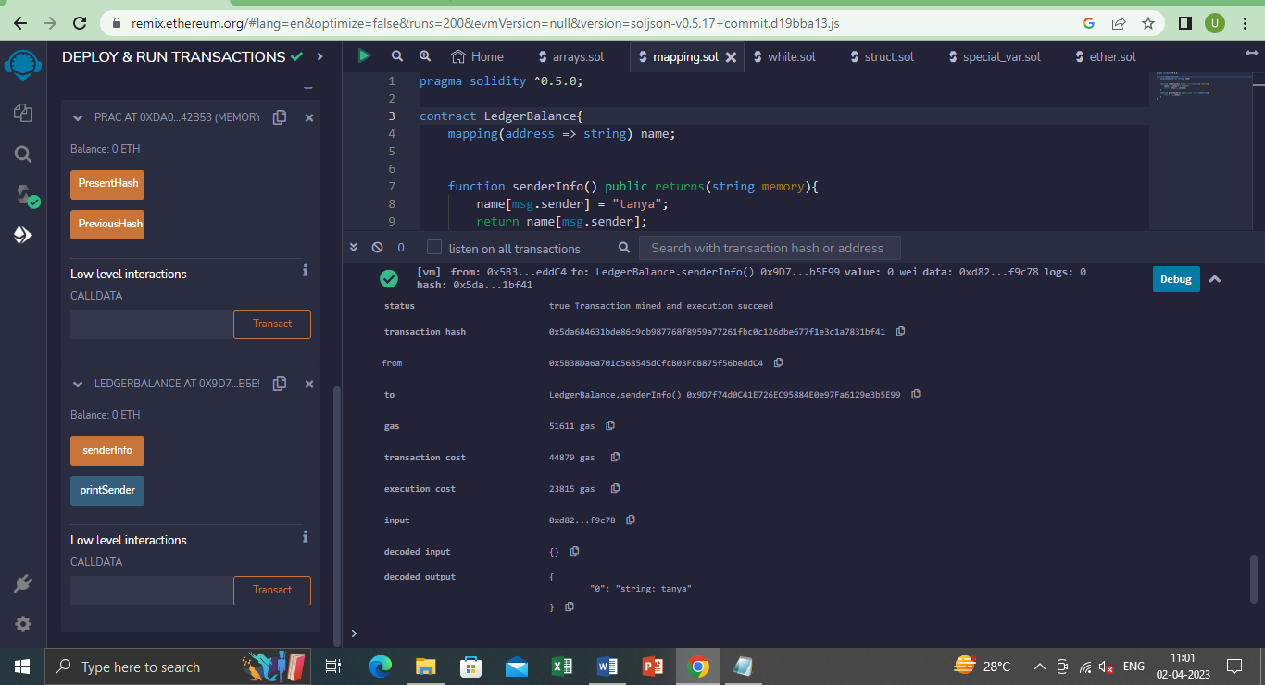

**PRACTICAL 6**

**Implement and demonstrate the use of the following in Solidity**

1. **.Functions**
2. **.View Functions**
3. **.Pure Functions**
4. **.Fallback Functions**
5. **.Function Overloading**
6. **.Mathematical Functions**
7. **.Cryptographic Functions**
8. **Functions**

**Code:**

pragma solidity ^0.8.0;

contract LedgerBalancee {

mapping(address => string) name;

function updateBalance() public returns(string memory) {

name[msg.sender]="tan";

return name [msg.sender];

}

function printsender() public view returns(address){

return msg.sender;

}

}

contract Test {

function getResult() public view returns(uint product, uint sum){

uint a = 1; // local variable

uint b = 2;

product = a * b;

sum = a + b;

//return(a*b, a+b);

}}

**Output:**

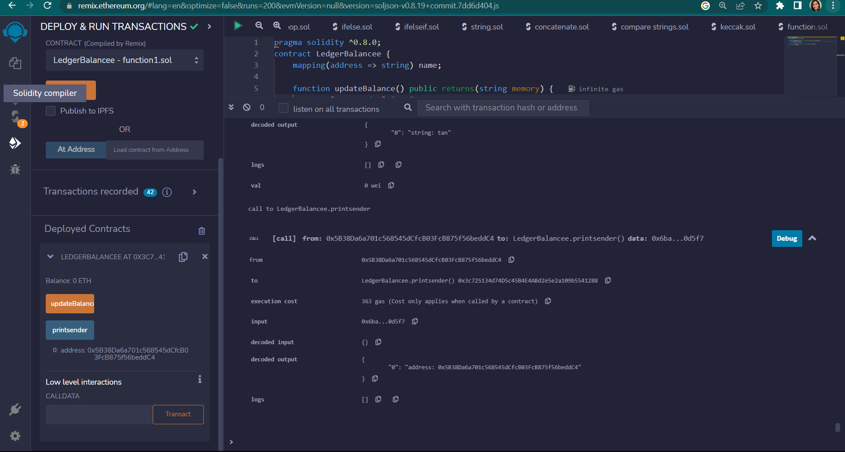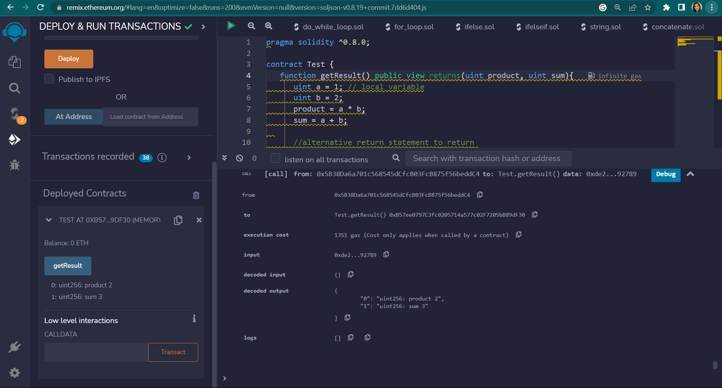

1. **.View Functions**

**Code**:

pragma solidity ^0.5.0;

contract Test{

function getResult() public view returns(uint product,uint sum){

uint a = 1; //local variable

uint b = 2;

product = a*b;

sum = a+b;

}

}

**Output**:

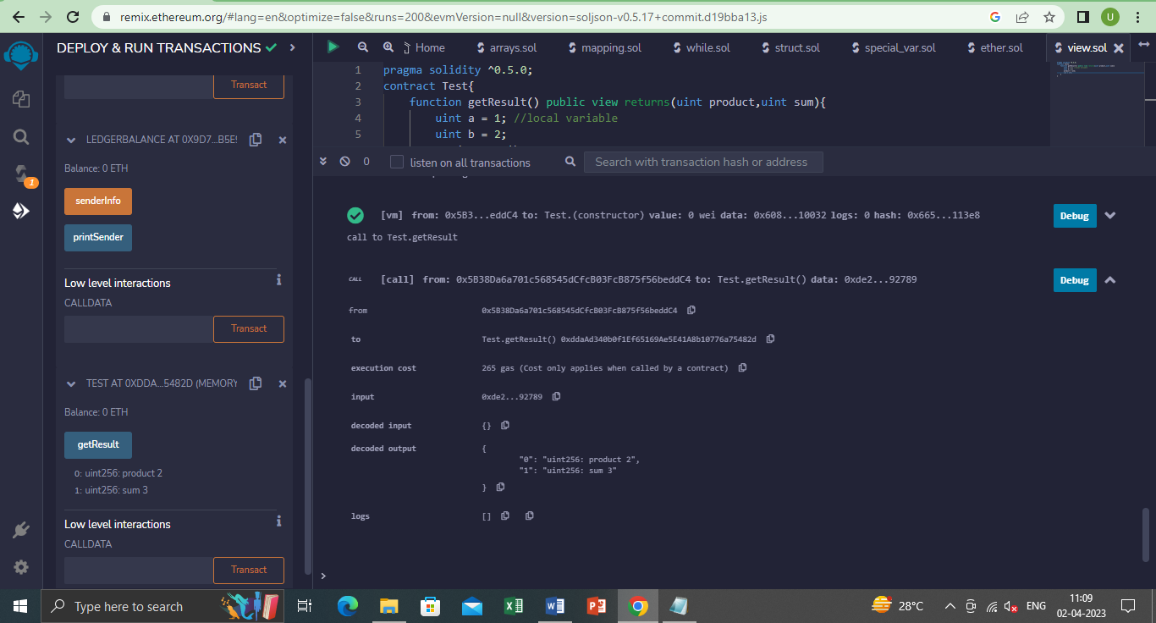

1. **.Pure Functions**

**Code**:

pragma solidity ^0.5.0;

contract Test{

function getResult() public pure returns(uint product,uint sum){

uint a = 1; //local variable

uint b = 2;

product = a*b;

sum = a+b;

}

}

**Output**:

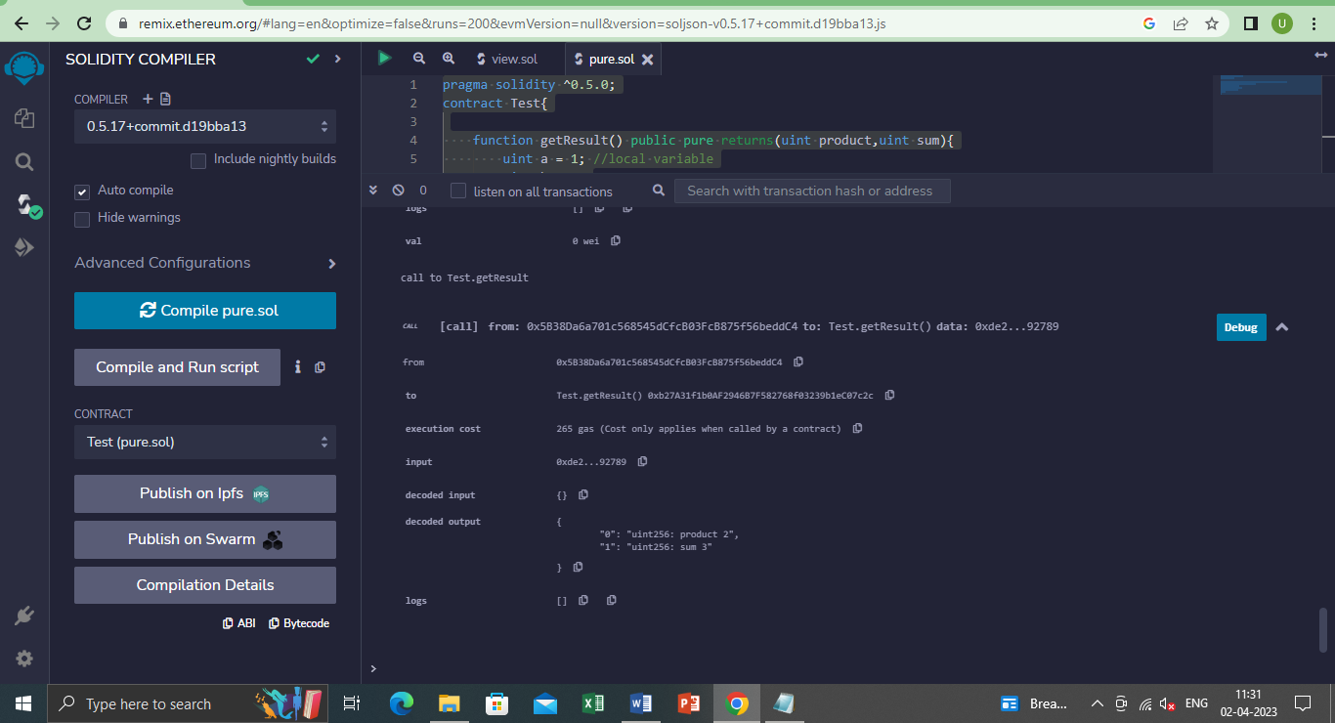

1. **.Fallback Functions**

**Code**:

pragma solidity ^0.5.12;

contract A {

uint n;

function set(uint value) external {

n=value;

}

//fallback function

function() external payable{

n=0;

}

}

contract example{

function callA(A a) public returns (bool){

(bool success,) = address(a).call(abi.encodeWithSignature("setter()"));

require(success);

address payable payableA=address(uint160(address(a)));

return(payableA.send(2 ether));

}

}

**Output**:

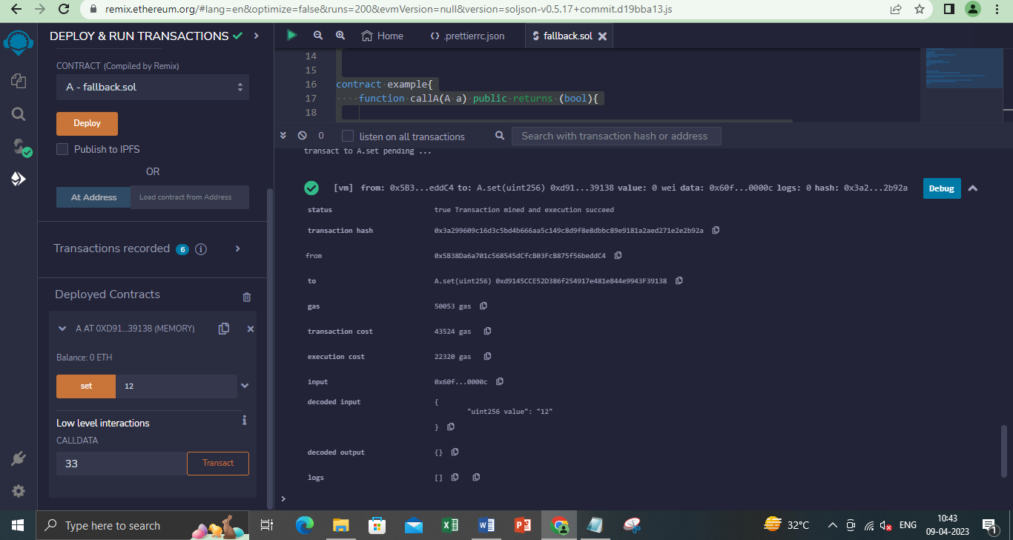

1. **.Function Overloading**

**Code**:

pragma solidity ^0.5.12;

contract Sample{

function getSum(uint a, uint b) public pure returns (uint){

return a+b;

}

function getSum(uint a, uint b, uint c) public pure returns (uint){

return a+b+c;

}

function callSumWithTwoArguments() public pure returns (uint){

return getSum(4,9);

}

function callSumWithThreeArguments() public pure returns (uint){

return getSum(4,9,6);

}

}

**Output**:

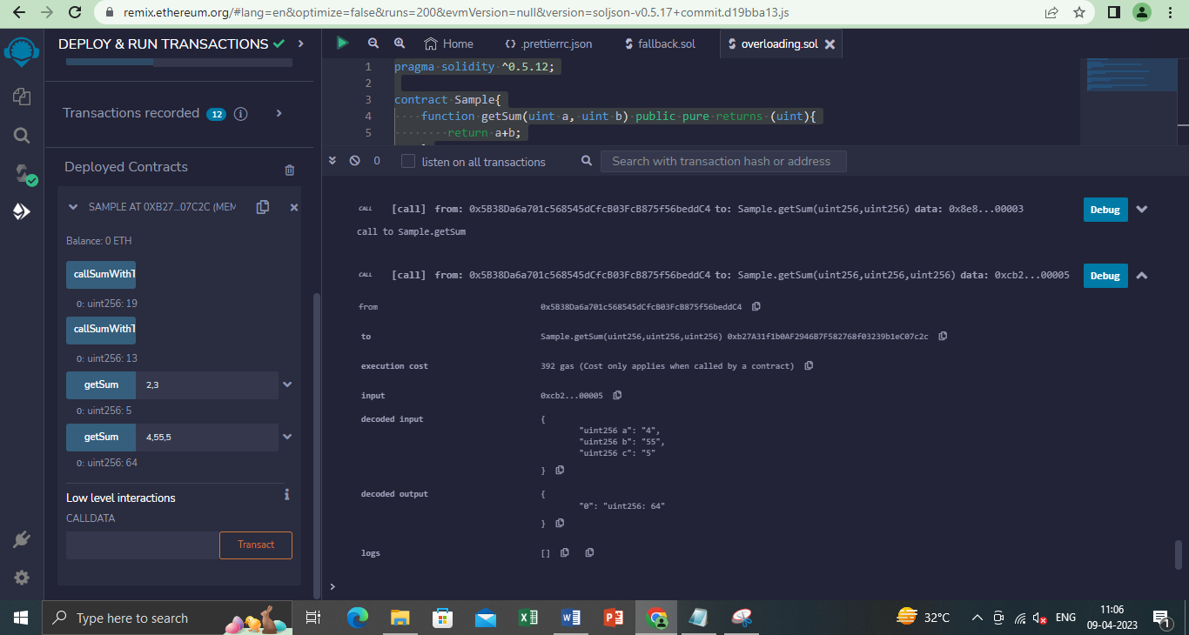

1. **.Mathematical Functions**

**Code**:

pragma solidity ^0.5.0;

contract Sample{

function callAddMod() public pure returns (uint){

return addmod(3,4,5);

//3+4 % 5

}

function callMulMod() public pure returns (uint){

return mulmod(3,4,5);

}

//3*4 % 5

}

**Output**:

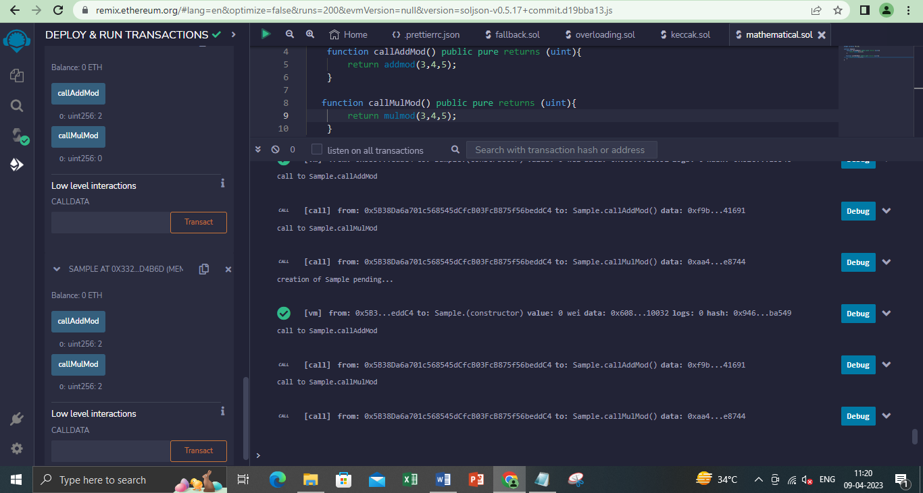

1. **.Cryptographic Functions**

**Code**:

pragma solidity ^0.5.12;

contract Test{

function callsha256() public pure returns(bytes32 result){

return sha256("Tanya");

}

function callkeccak256() public pure returns(bytes32 result){

return keccak256("Tanya");

}

}

**Output**:

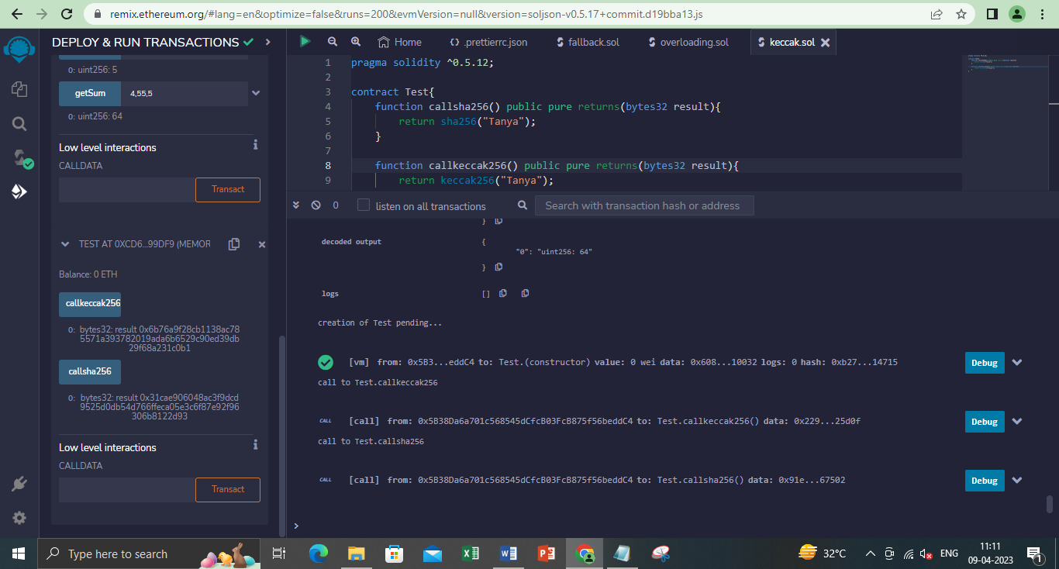

**PRACTICAL 7**

**Implement and demonstrate the use of the following in Solidity**

1. **Contracts**
2. **Inheritance**
3. **Constructors**
4. **Abstract class**
5. **Interfaces**
6. **Contracts**

**Code:**

pragma solidity ^0.8.0;

contract Storage

{

uint public setData;

function set(uint x) public{

setData = x;

}

function get() public view returns (uint) {

return setData;

}}

**Output:**

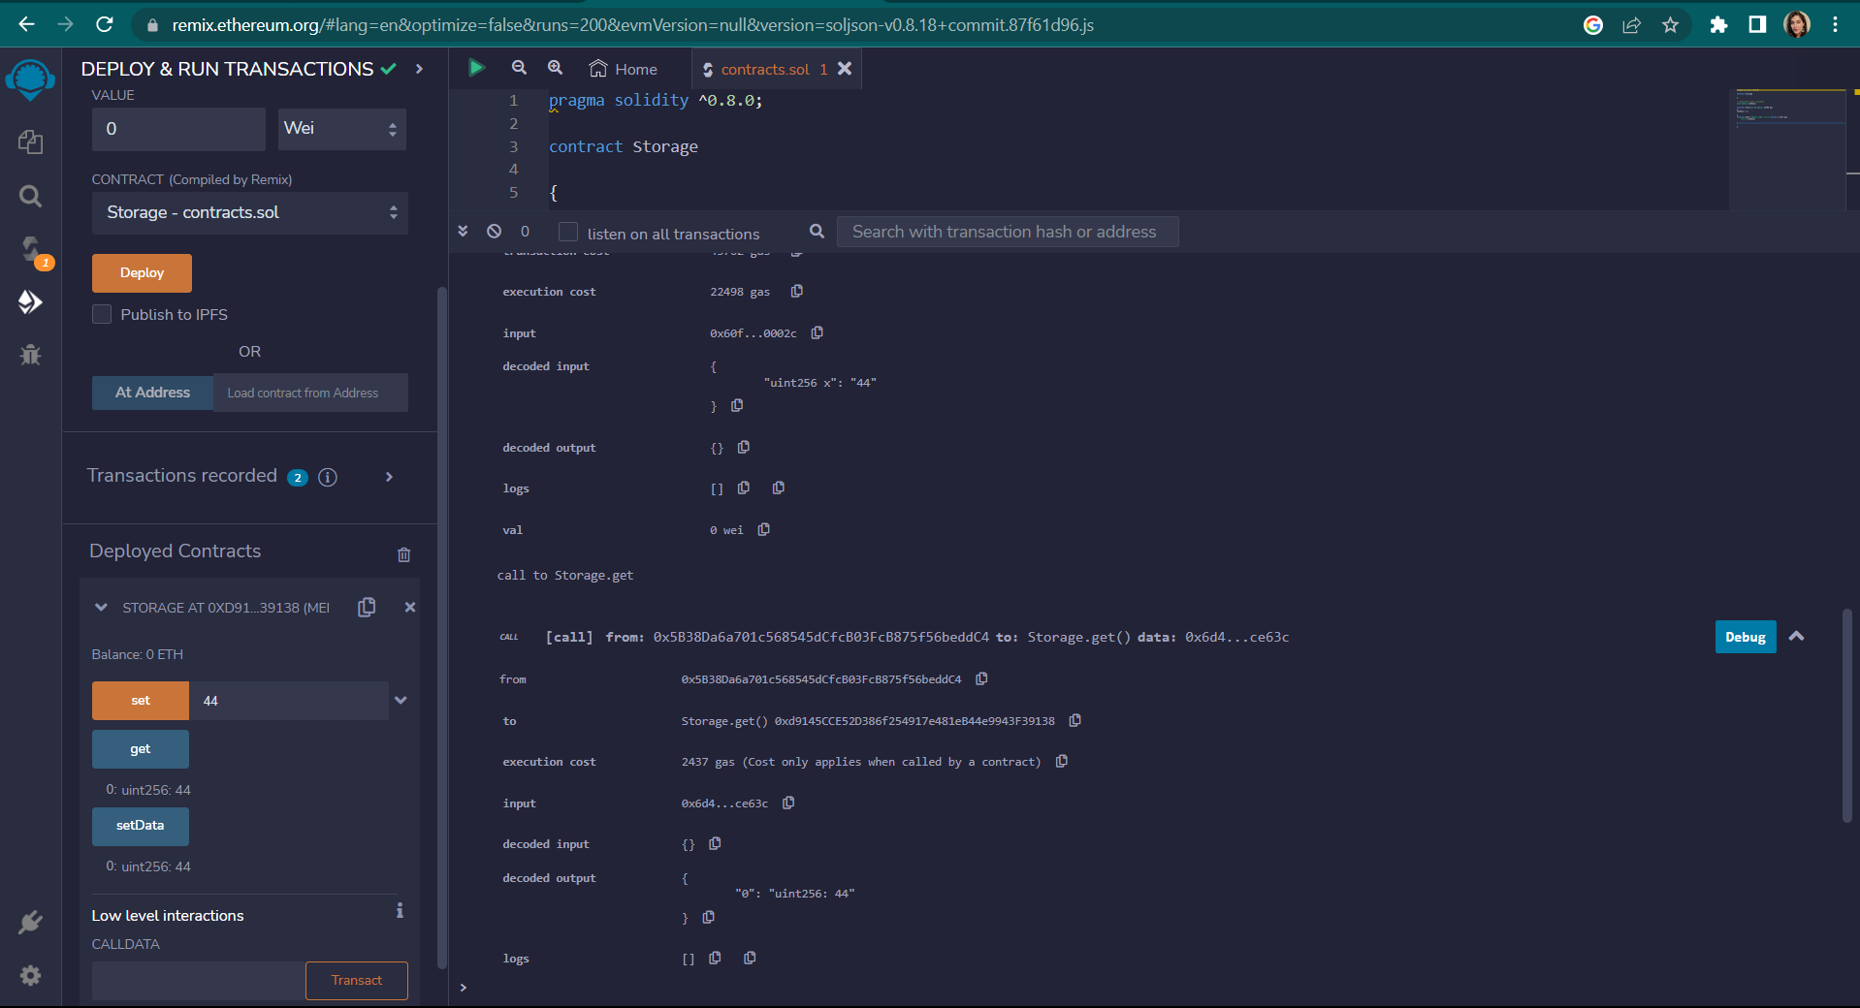

1. **Inheritance**
   1. **Single inheritance**
   2. **Multiple inheritance**
   3. **Multilevel inheritance**
2. **Single Inheritance:**

**Code:**

pragma solidity 0.5.0;

contract parent{

uint internal sum;

function setValue() external {

uint a = 10;

uint b = 25;

sum = a + b;

}

}

contract child is parent{ //defining the child contract

function getValue(

) external view returns(uint) {

return sum;

}

}

contract caller {

child cc = new child();

function testInheritance(

) public returns (uint) {

cc.setValue();

return cc.getValue();

}

}

**Output:**

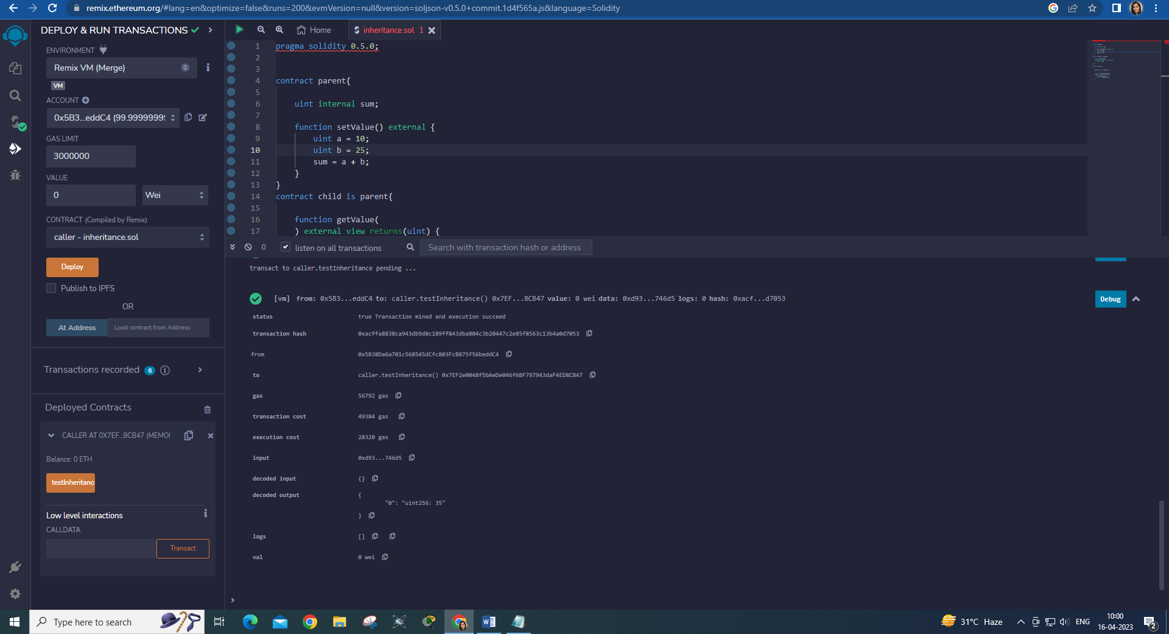

1. **Multiple Inheritance:**

**Code:**

pragma solidity ^0.5.0;

contract A {

string internal x;

function setA() external {

x = "Multiple Inheritance";

}

}

contract B {

uint256 internal pow;

function setB() external {

uint256 a = 2;

uint256 b = 20;

pow = a**b;

}

}

contract C is A, B {

function getStr() external view returns (string memory) {

return x;

}

function getPow() external view returns (uint256) {

return pow;

}

}

contract caller {

C contractC = new C();

function testInheritance() public returns (string memory, uint256) {

contractC.setA();

contractC.setB();

return (contractC.getStr(), contractC.getPow());

}

}

**Output:**

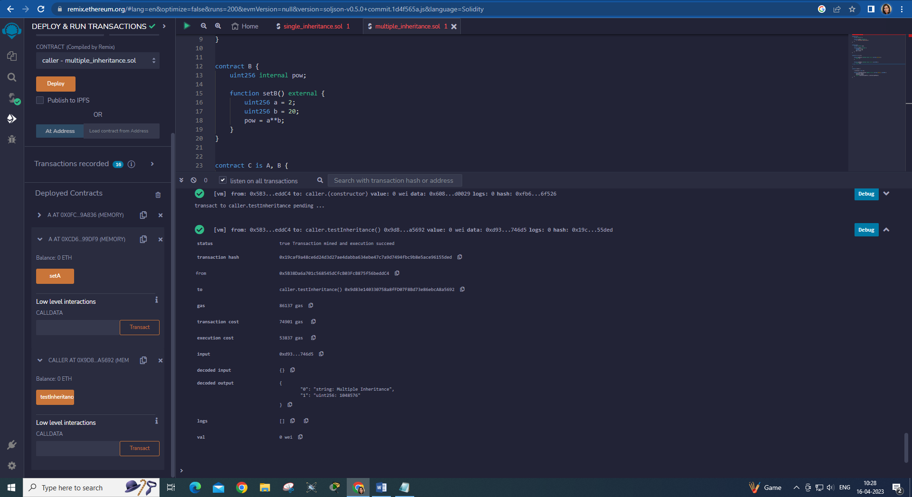

1. **Multilevel Inheritance:**

**Code:**

pragma solidity ^0.5.0;

contract A {

uint256 internal x;

function setX() external {

x=10;

}

}

contract B is A {

uint256 internal y;

function setY() external {

y=20-x;

}

}

contract C is B{

function getY() external view returns(

uint){

return y;

}

}

contract caller {

C cc = new C();

function testInheritance(

) public returns (

uint256) {

cc.setX();

cc.setY();

return cc.getY();

}

}

**Output:**

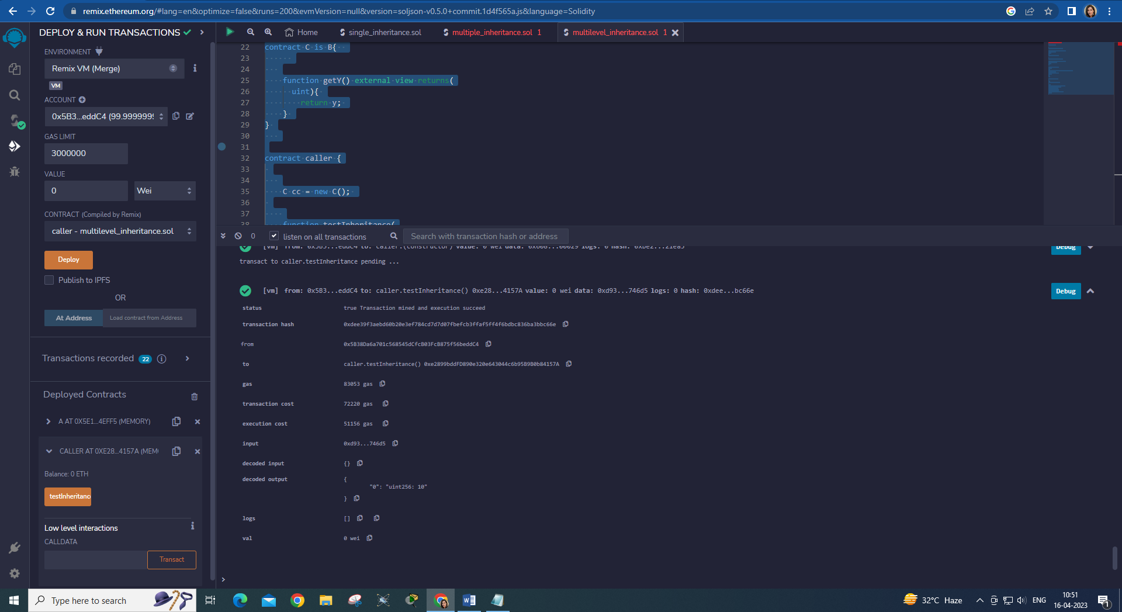

1. **Constructors**

**Code:**

// Solidity program to demonstrate

// creating a constructor

pragma solidity ^0.5.0;

// Creating a contract

contract constructorExample {

// Declaring state variable

string str;

constructor() public {

str = "Tanya 27, MSC IT P2";

}

// Defining function to

// return the value of 'str'

function getValue(

) public view returns (

string memory) {

return str;

}

}

**Output:**

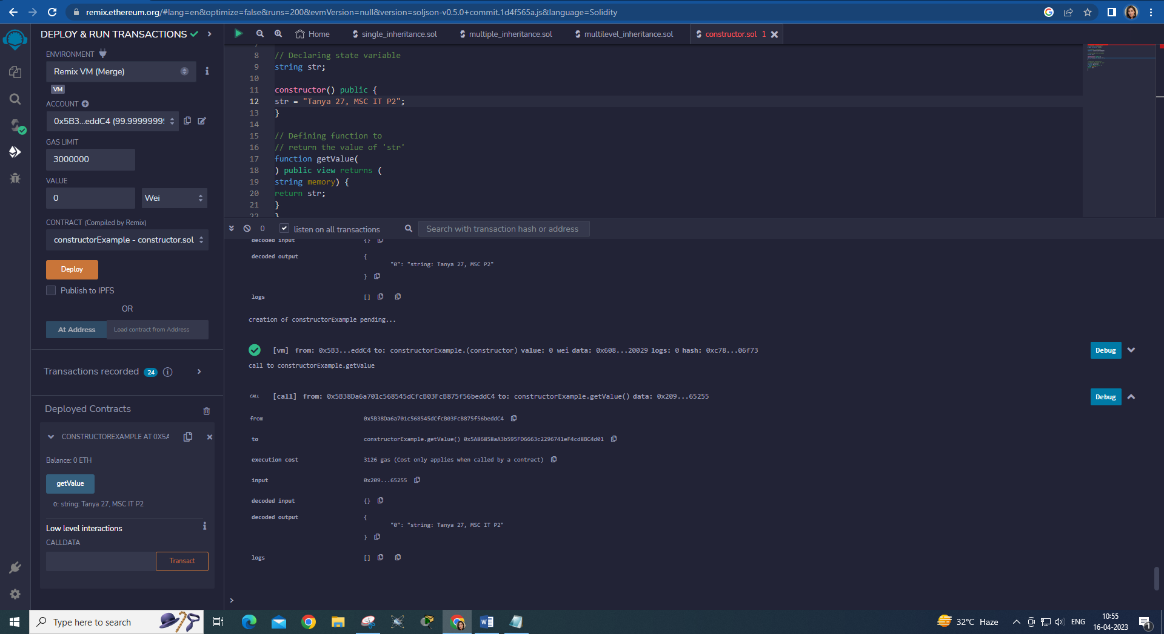

1. **Abstract class**

**Code:**

pragma solidity ^0.5.0;

contract A {

function getResult() public view returns(uint);

}

contract B is A {

function getResult() public view returns(uint) {

uint a = 100;

uint b = 201;

uint result = a * b;

return result;

}

}

**Output:**

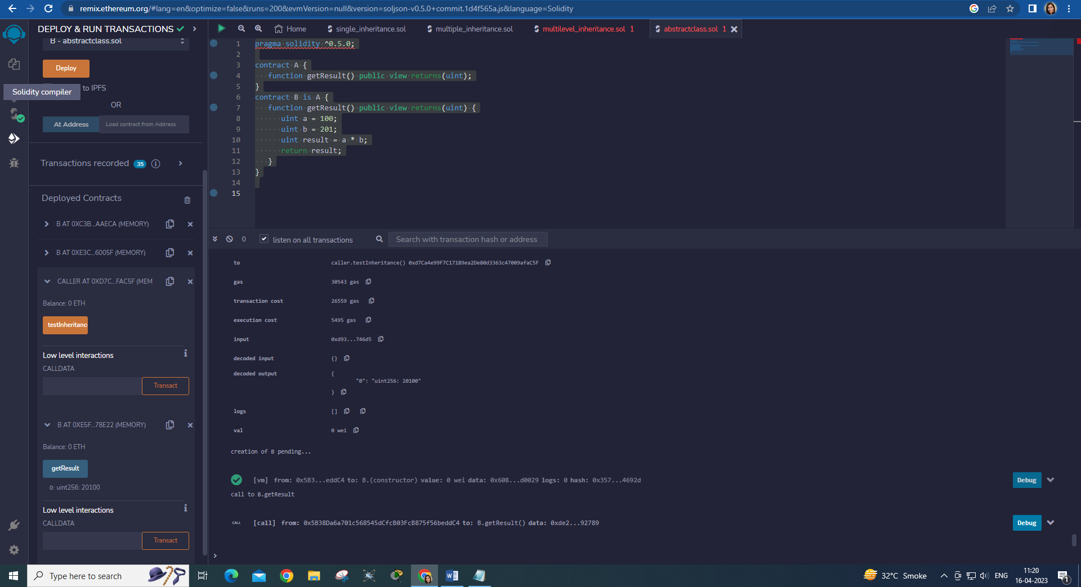

1. **Interfaces**

**Code:**

pragma solidity ^0.5.0;

interface Calculator {

function getResult() external view returns(uint);

}

contract Test is Calculator {

constructor() public {}

function getResult() external view returns(uint){

uint a = 1;

uint b = 2;

uint result = a + b;

return result;

}

}

**Output:**

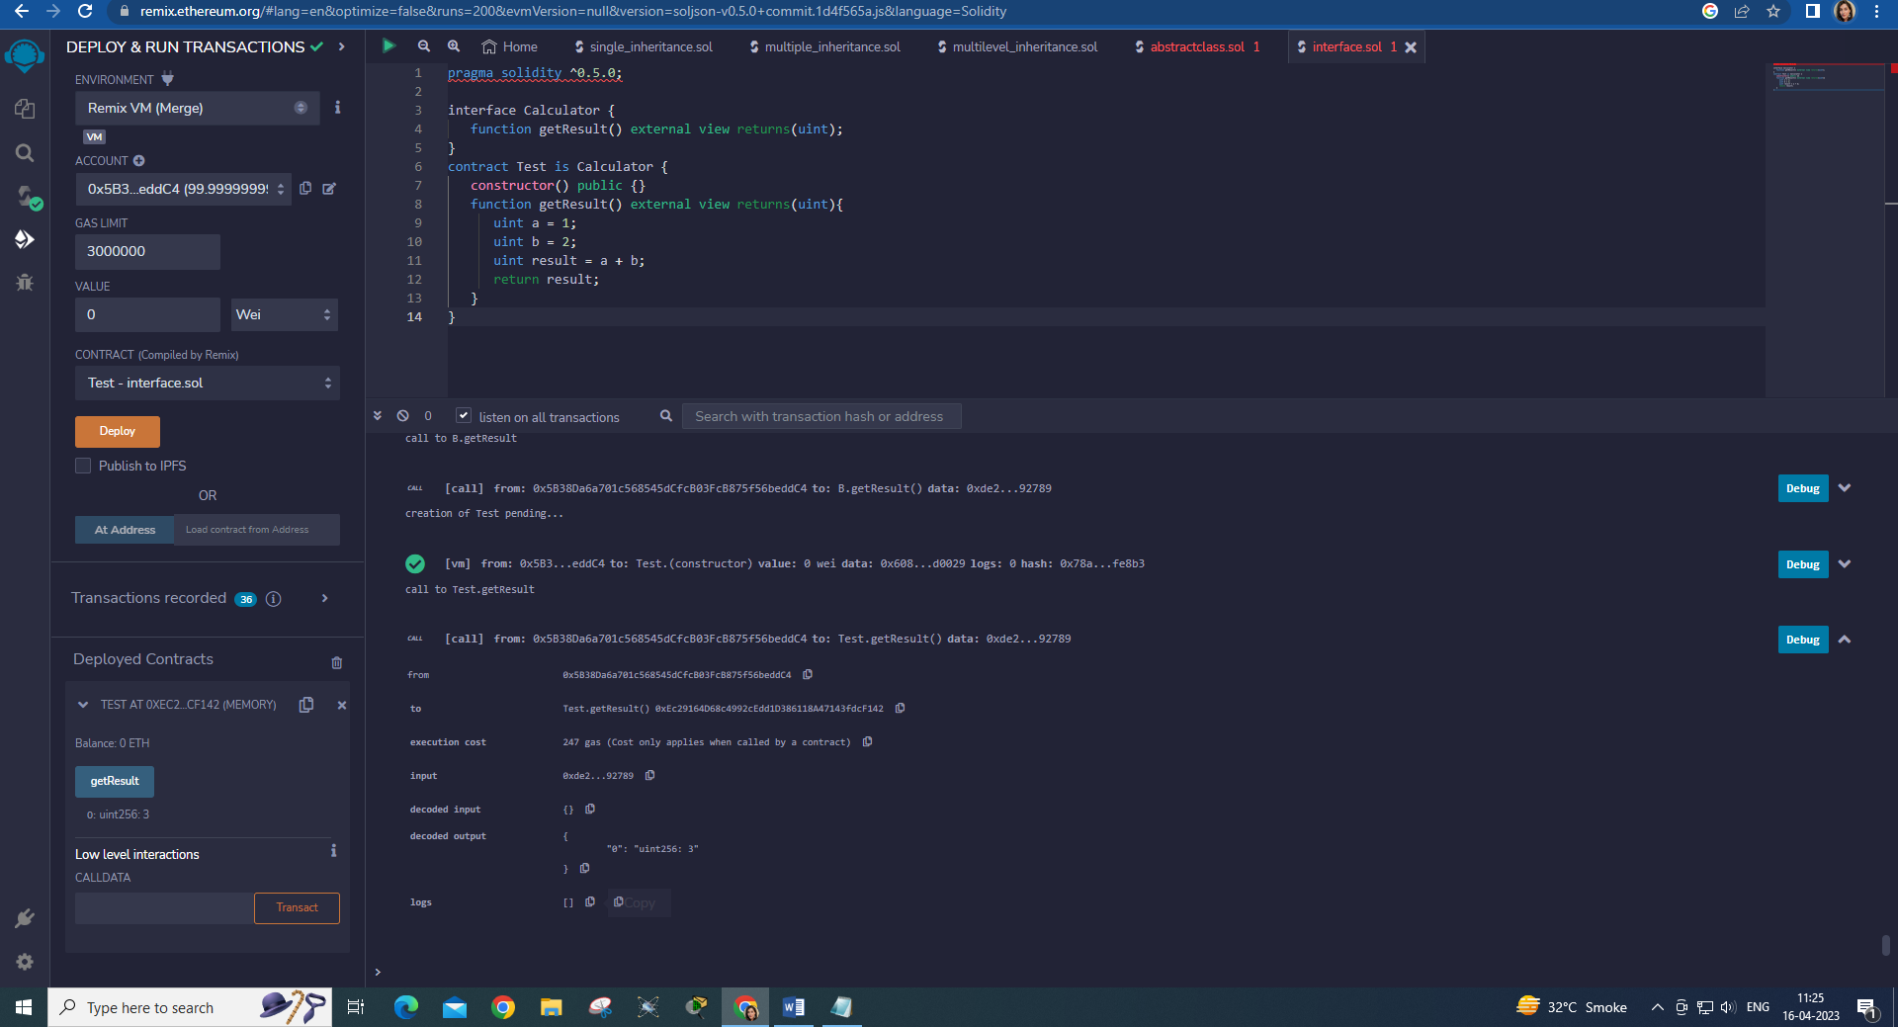

**PRACTICAL 8**

**Implement and demonstrate the use of the following in Solidity**

1. **Libraries**
2. **Assembly**
3. **Events**
4. **Error handling**
5. **Libraries**

**Code:**

**Libraries.sol:**

pragma solidity ^0.8.0;

import "./MathUtils.sol";

contract calculator{

using MathUtils for uint;

function getSum(uint a, uint b) public pure returns(uint){

return a.add(b);

}

}

**MathUtils.sol:**

pragma solidity ^0.8.0;

library MathUtils{

    function add(uint x, uint y) public pure returns(uint){

        return x+y;

    }

}

**Output:**

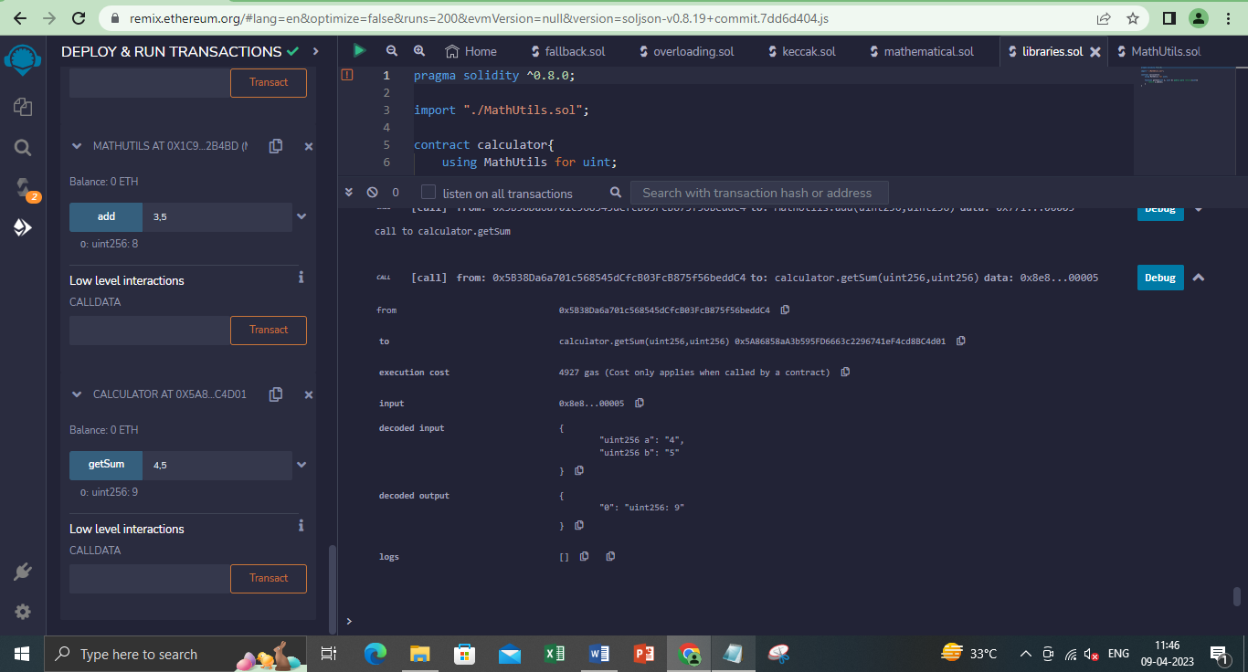

1. **Assembly**

**Code:**

pragma solidity ^0.5.0;

contract InlineAssembly {

function add(uint a) public view returns (uint b) {

assembly {

let c := add(a, 56)

mstore(0x80, c)

{

let d := add(sload(c), 22)

b := d

}

b := add(b, c)

}

}

}

**Output:**

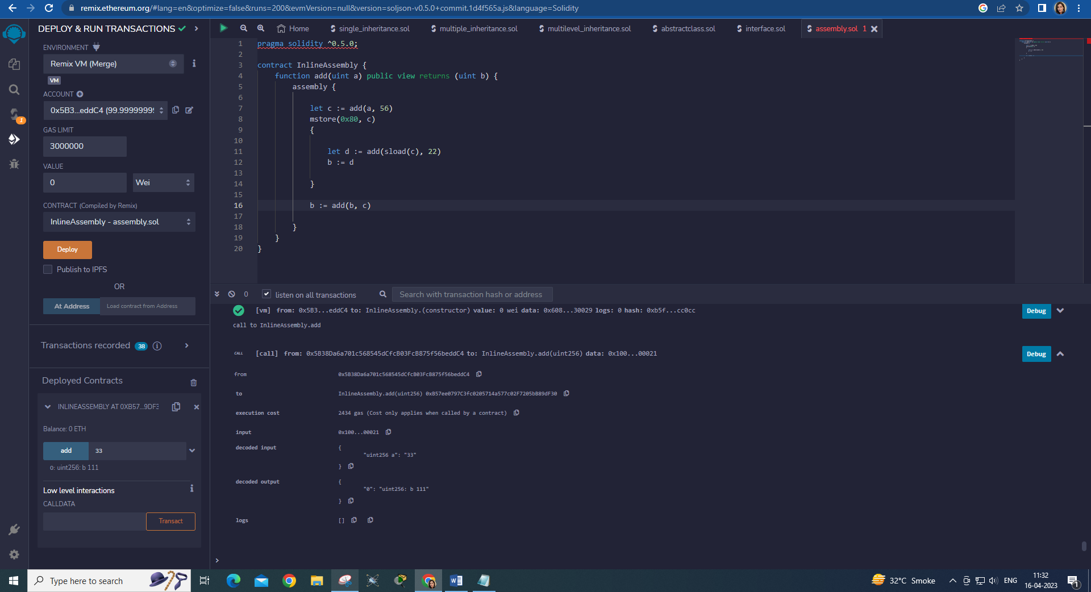

1. **Events**

**Code:**

pragma solidity ^0.4.21;

contract eventExample {

uint256 public value = 0;

event Increment(address owner);

function getValue(uint _a, uint _b) public { // _a, _b is instance variable (used internally only)

emit Increment(msg.sender);

value = _a + _b;

}

}

**Output:**

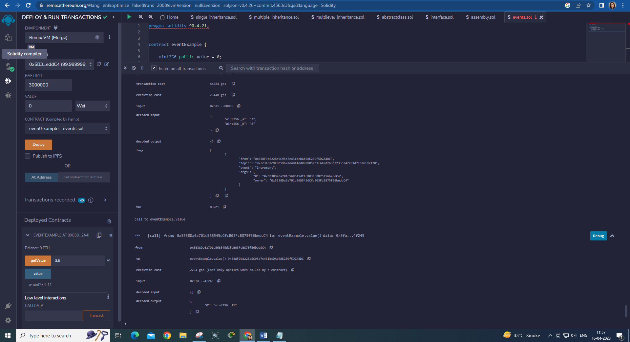

1. **Error Handling**
   1. **Require**
   2. **Assert**
   3. **Revert**
2. **Require:**

**Code:**

pragma solidity ^0.5.0;

contract requireStatement {

function checkInput(uint _input) public view returns(string memory){

require(_input >= 0, "invalid uint8");

require(_input <= 255, "invalid uint8");

return "Input is Uint8";

}

function Odd(uint _input) public view returns(bool){

require(_input % 2 != 0);

return true;

}

}

**Output:**

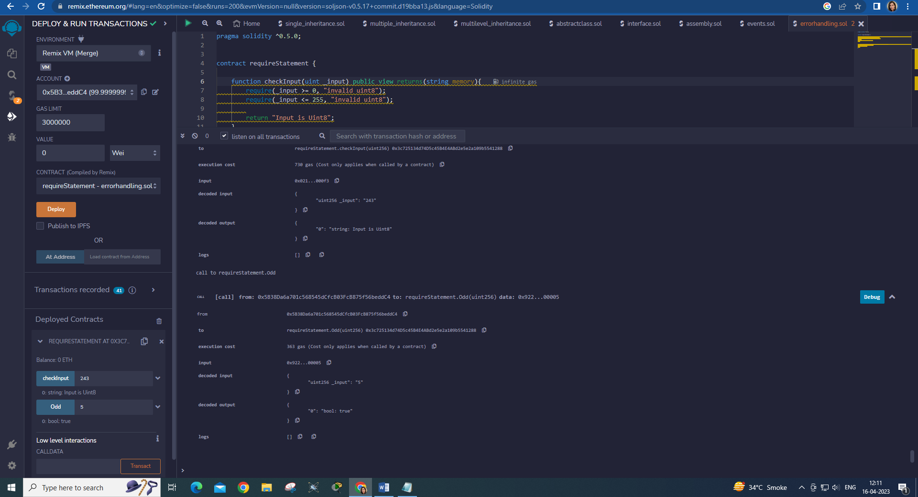

1. **Assert:**

**Code:**

pragma solidity ^0.5.0;

contract assertStatement {

bool result;

function checkOverflow(uint _num1, uint _num2) public {

uint sum = _num1 + _num2;

assert(sum<=255);

result = true;

}

function getResult() public view returns(string memory){

if(result == true){

return "No Overflow";

}

else{

return "Overflow exist";

}

}

}

**Output:**

**Overflow exists:**

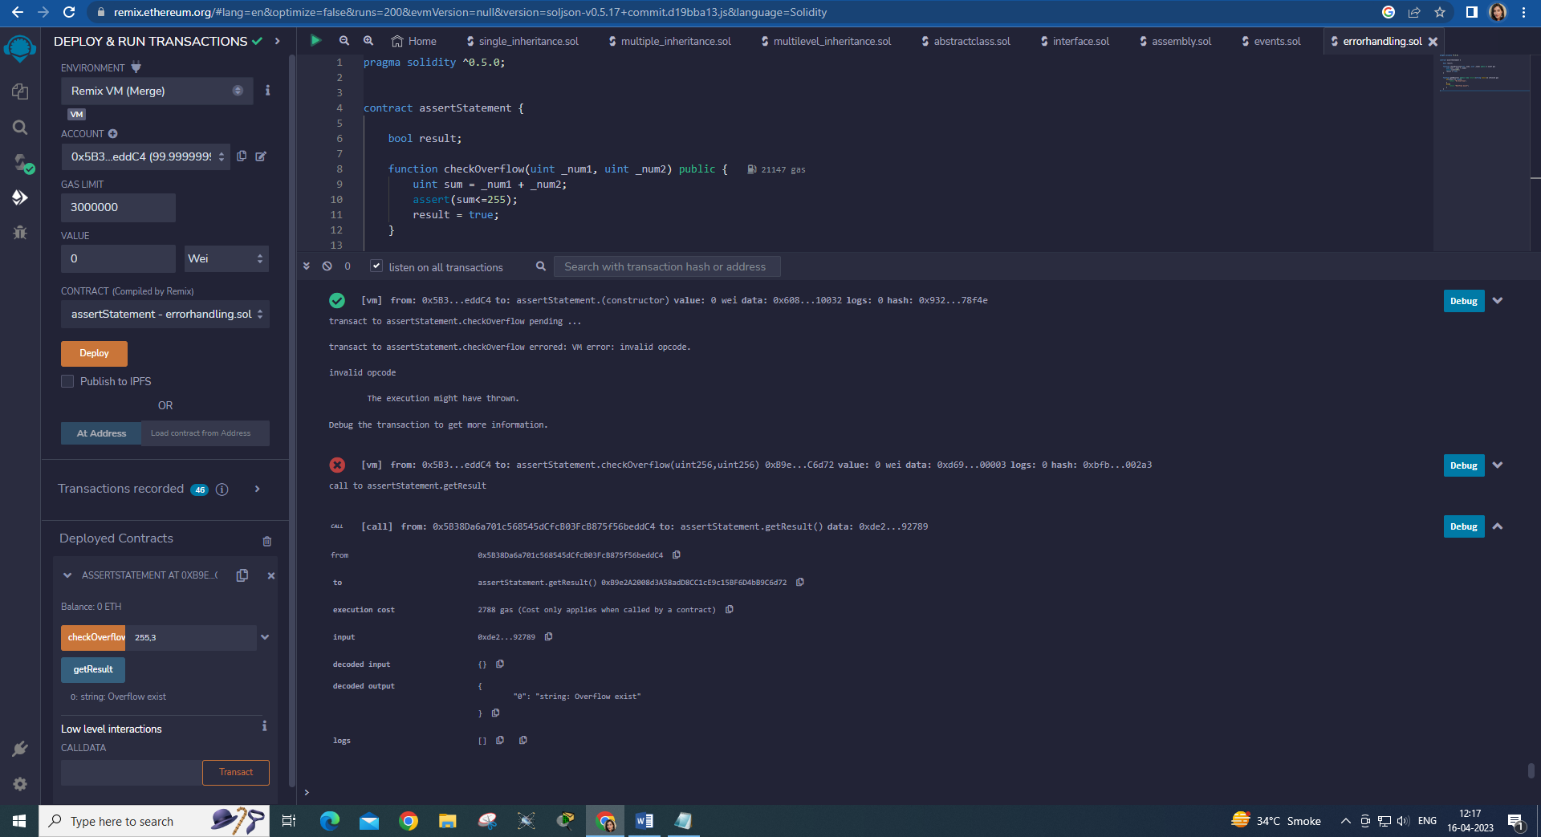

**No Overflow:**

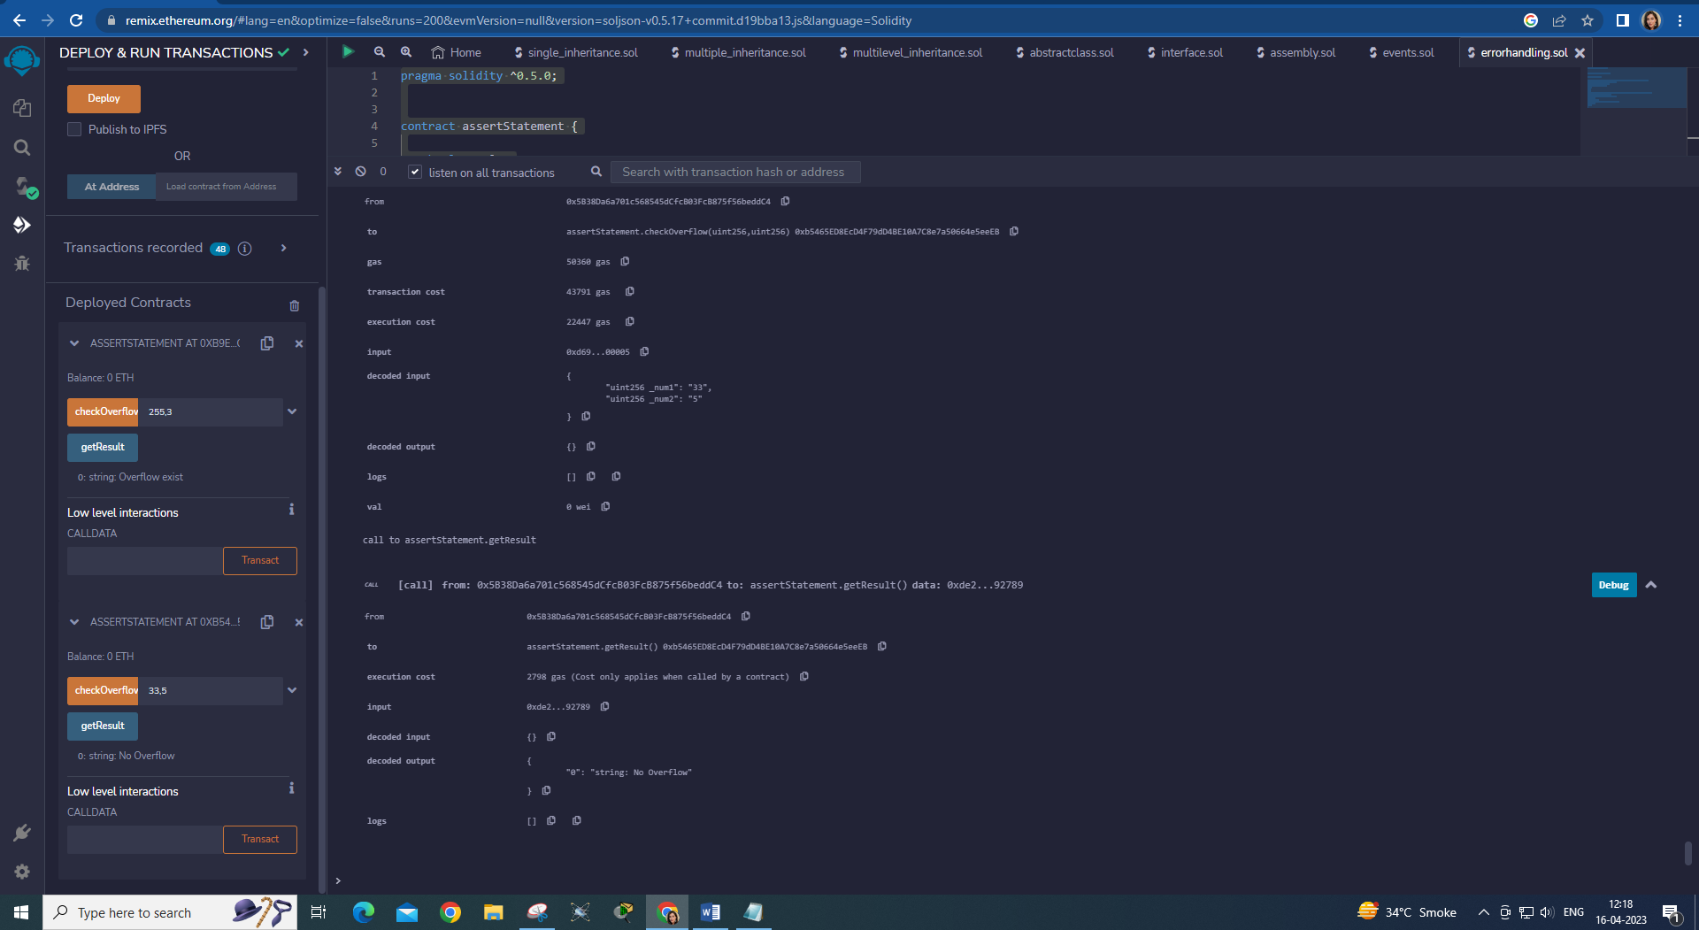

1. **Revert:**

**Code:**

pragma solidity ^0.5.0;

contract revertStatement {

function checkOverflow(uint _num1, uint _num2) public view returns(string memory, uint){

uint sum = _num1 + _num2;

if(sum < 0 || sum > 255){

revert(" Overflow Exist");

}

else{

return ("No Overflow", sum);

}

}

}

**Output:**

